KHAZAR UNIVERSITY

School: Architecture, Engineering and Applied Sciences
Department: Computer Science
Major: Computer Engineering and Management

MASTER THESIS

Title: Development of audio visual learning system.

MS Student: Rena Rzazade
Supervisor: Ph.D, Associate Professor Leyla Muradkhanli

March-2010

Abstract

This thesis consists of three chapters. In the first chapter explored the subject of media and its effect on education. In the second chapter deals with technology of such systems. The third is brought to work on the audio visual learning system.
The study and development of educational multimedia electronic techniques is aimed to provide assistance to teachers and trainers.
It was proposed to establish a multimedia system – visual and sound system – with the help of computer technologies in order to study any material without a teacher, i.e. independently. With the help of computer technology to create a audio and visual system. I have developed a program by using Action Script which is integrated into Adobe Flash.
The practical value of this work is to help students of our university to acquire computer skills. Thus, the book will give the reader an opportunity to clearly see and record the necessary materials. The book is popular among students because it is easy to understand and read. This makes the book much valuable for our university.

xÜlasə

Dissertasiya üç bölmədən ibarətdir. Birinci fəsil media mövzusunu və onun təhsilə təsirini öyrənir. İkinci fəsildə bu cür sistemlərin yaradılması texnologiyasına baxılır. Üçüncü fəsildə isə audio-vizual dərs vəsaitinin hazırlanması təqdim olunur.
Audio-vizual dərs vəsaitlərinin tədqiqi və hazırlanması təlimçilərə və müəllimlərə kömək məqsədi üçündür.
Hər hansı bir materialı müəllimin köməyi olmadan, sərbəst şəkildə mənimsəmək üçün multimedia sistemi yaratmaq təklif olundu. Kompyuter texnologiyalarından istifadə etməklə audio və vizual sistem yaratmaq. Mən Adobe Flash proqramına inteqrasiya edilən ActionScript proqramlaşdırma dilindən istifadə etməklə proqram hazırladım.
İşin əhəmiyyəti universitəmizin tələbələrinə kompyuter bacarıqlarına yiyələnməkdə kömək etməkdir. Beləliklə, tələbə kitabı bitirdikdən sonra lazımı materialları əyani surətdə görə və qeydə ala bilər. Kitab tələbələr tərəfindən asan oxunub, başa düşüldüyü üçün geniş yayılmışdır. Buna görə də verilmiş materialın seçilməsi universitəmiz üçün çox əhəmiyyətlidir.

TABLE OF CONTENTS

Introduction……….………………………………………………………………........……. 5

CHAPTER I. Multimedia Resources in Education.

1.1 The concept of multimedia ………………...……………………..……..….….…………8

1.2 Properties of multimedia resources ………………………………………… ......……….10

1.3 Basic advantages of using multimedia in education ……..…………………...…....…… 13

1.4 Main problems and disadvantages of multimedia application in education…………………………………………………………………………...…………14

1.5 Application of multimedia models in the study of complex processes and phenomena……………………………………………………………………………………16

CHAPTER II The technology of Multimedia resources?

2.1 What is needed to create multimedia resources?......... …………………...……...………16

2.2 The technology of multimedia development ..…………………………………….……..16

2.3 Criteria for selection of high-quality educational multimedia resources …………….…..19

2.4 System requirements for teachers using multimedia resources in professional activities ……………...............................................................................................................………...20

CHAPTER III. Development of Audio Visual Learning System.

3.1 Adobe Flash………………………………………………………………………………22

3.2 Structure of system ……………………………………………………………………….25

3.3 Main buttons ……………………………………………………………………………...27

3.4 Dictionary…………………………………………………………………………………32

3.5 Animation…………………………………………………………………………………44

3.6 Video …………………………………………………………………………………..…48

3.7 SWF ………………………………………………………………………………….…...54

3.8 Working with sound………………………………………………………………………57

Conclusion ……………………………………………………………………………..….….61
Literature …………………………………………………….……………………………….62

Introduction

The research deals with the adoption of state-of-the-art computer and telecommunication technologies in teaching and methodical process. The introduction of computer technology in secondary schools made it necessary to develop education programs that would enable learners to review the material, as well as self-train without the assistance of a tutor. In addition, there is a great need to set up programs which allow testing learners’ knowledge. These programs give learners an opportunity to work separately.
The materials provided by all these programs are designed for such conditions that for various reasons, the learner is not able to ask the teacher again or there is no educational institution he/she could have the training. Computer programs are also used to repeat the lessons learnt.
Multimedia systems appeared in result of the development of scientific and technological progress and the establishment of modern computer and telecommunication technology, which stores, processes and provides various types of information. These systems are capable of cardinally changing the approach to education and improve the process of training specialists in all levels of education. They help speed up the course and turn it into the play training. It was the television that took the first steps in this field when it began to broadcast animal life and talk about the important moments of our history i.e. illustrating historical events with exposures and library video pictures. Thus, they delivered information to spectators in the form of a documentary film. Information obtained in this way, was better to remember and drew much interest.
The research should be considered timely, as teaching and methodological package of electronic means is convenient and easily assimilated by the students of the younger generation i.e. youth. Ни для кого не секрет что учащиеся школ и вузов более легко осваивают компьютерную грамотность и проявляют интерес к информационным технологиям. It's no secret that students in schools and universities master computer skills more easily and draw much interest in information technologies. Они больше времени проводят в Интернет пространстве и компьютер занимает большое место в их жизни. They spend more time in the Internet and the computer plays an important role in their lives. World scientists have proved that students easily learn and memorize the information presented vividly and visually. At present, it is almost impossible to find any training area without electronic data multimedia encyclopedia, reference books and teaching aids, each of which is a hypermedia system, which combines text, photos, video clips in relation with each other. Much of such information is available on the Internet in the form of websites.
The establishment of specialized multimedia technology made it possible to introduce different and structured information through modern ICT resources.
Multimedia uses different software and hardware to have the most effective impact on the user. Through application of graphic, audio (sound) and visual information provided in multimedia products, these techniques have greater emotional charge on the user and is considered as a way of entertainment. Of course, when the student reads the text and tries to imagine how it happens in real life, the process of learning will take little longer, but if one initially explains him/her the process visually, the student will memorize not only text and figures, but also the image. Many argue that multimedia training program alienates students from books, as well as learning lessons directly from books. Personally, I disagree with this statement since reading the material several times and then watching the animation and hearing it allows remembering it for a long time and understanding. Furthermore, it contributes to the development of visual memory. It has been proven experimentally that student is capable of mastering 1000 reference units of information per minute through verbal presentation of given material whereas it is 100 000 units together with vision. So, it is obvious that application of multimedia techniques based on visual and aural presentation of teaching material in educational process is of high efficiency.
The study and development of educational multimedia electronic techniques is aimed to provide assistance to teachers and trainers.
It should be noted that as all people differ, each masters the teaching material in different speed. If some students failed to grasp the essence of the topic after the explanation of the teacher, it would be easier to master it with the help of animation presentation via image, video and sound. Another advantage is that the student can see the paragraph several times and master it better. In this research, I would like to consider and develop a multimedia program to assist learners to acquire basic computer skills since we live in the information society and our lives are mostly related to ICT.
Scientific novelty. Было предложено создать мультимедийную систему для изучения какого-либо материала без педагога т.е самостоятельно. С помощью компьютерных технологий создать визуальную и звуковую систему. С моей стороны была разработана программа с помощью языка программирования Action Script который интегрирован в программу Adode Flash.It was proposed to establish a multimedia system – visual and sound system – with the help of computer technologies in order to study any material without a teacher, i.e. independently. I have developed a program by using Action Script which is integrated into Adobe Flash. This program allows one to create 2D animation. I took the book "Introduction to computer science” by Prof. Leila Muradkhanli as a principle in my work. On the basis of the book, I structured the program and developed the animations. The experience I gained while working on a state project on establishment of multimedia system for textbooks for students from fifth to eleventh form, helped me to structure and designed the program and its skeleton.
First, I conducted a research and studied the developed systems, on what programming languages they have been developed, and which graphics are used in the development of such programs. The correct illustration of the material and development of animation on the text takes the key role in this process. Animation must be accompanied with sound, i.e. dubbing material, as well as the music.
The practical value of this work is to help students of our university to acquire computer skills. Thus, the book will give the reader an opportunity to clearly see and record the necessary materials. The book is popular among students because it is easy to understand and read. This makes the book much valuable for our university.
This thesis consists of two chapters. В первой главе я хочу рассмотреть мультимедиа как предмет. In the first chapter, I would like to consider multimedia as a subject including itsЕе характеристики, применения, виды и особенности. features, applications, types and characteristics and to examine the multimedia system for teaching purposes. In the second chapter will get acquainted with the model of multimedia system and show Покажу принципы ее создания и работы. the principles of its development and work.

CHAPTER 1

1.1. Понятие мультимедиа 1.1. The concept of multimedia
Прежде чем начать говорить о «Мультимедиа» и о видах и формах представления информации следует начинать с понятия информация. Before we start talking about Multimedia and the types and forms of presentation of information, we need to start with the notion of information.
The term “information” is derived from the Latin “informatio – clarification, statement”. Жизнь и развитие человечества способствовали постоянному накоплению исторических, научных, культурных и многих других знаний, основанных на информации. Life and human development have contributed to the constant accumulation of historical, scientific, cultural and much other knowledge-based information. Однако в связи с бурным развитием науки и техники в середине ХХ века роль информации неизмеримо возросла. Само понятие информации стало объектом постоянных исследований в различных областях научной деятельности человека. However, due to the rapid development of science and technology in the mid-twentieth century, the role of information has grown immeasurably. The very notion of information has become the object of continuous research in various fields of scientific activities.
Study of information and its processing must begin with its presentation techniques, as the further technology of presentation and information processing possibilities of its application in traditional and open education are determined by the specific features of teaching methods. Therefore, effective presentation of information, including the teaching material, is considered one of the most important problems of the education. It has become more significant lately in connection with the application of information technologies in distance learning and the need to present teaching information through computer screen. The problem is further complicated by the fact that in recent years the amount of information on all academic subjects has increased in a considerable manner while \the time spent on their study remained unchanged. Иначе говоря, стало очень много учебной информации, изучение которой требуется для подготовки специалистов. In other words, educational information has become a lot and their study required the training of specialists.
Types and forms of presentation depend substantially on the forms of existence of various information. All the information a human being is capable of perceiving can be divided into two main classes:
- по органам чувств: оптическая, акустическая и осязательная; through senses: an optical, acoustic and tactile;
- по технике: текстовая, акустическая, использующая изображения, цветовая. through technology: textual, acoustic, using images, color.
The most important information can be provided, for example, not only visually, but also accompanied by soundtrack or other ways affecting the sense organs. The visual information allows students to take a decision without usual long-term thinking.
1. Информация, воспринимаемая слуховым аппаратом человека, так называемая звуковая информация; 1. Information, perceived by hearing s, is called sound information;
2. 2. Информация, воспринимаемая зрением человека, так называемая зрительная или визуальная информация, включающая текст и графические изображения-картинки; Information perceived by sight is called visual or visual information, including text and graphics or pictures;
3. 3. Информация, частично воспринимаемая сенсорной системой человека при работе с помощью специальных технических средств с видеороликами, теле-объектами и др. - сенсорная или тактильная информация. Information partially perceived by sensory system with the help of special technical aids of film clips, television facilities, etc. is called sensory or tactile information.
Представление разнотипной и, как правило, структурированной информации с использованием современных средств ИКТ стало возможным, благодаря появлению специализированной технологии мультимедиа. Introduction of structured information of various types using modern ICT techniques became available thanks to the specialized multimedia technology.
The multimedia systems have revolutionized many areas of human activity: computer training, business and other fields of professional activities. One of the most extensive applications of multimedia technologies was carried out in education.
Мультимедиа обеспечивают возможность улучшения обучения и повышение качества обучения за счет применения современных способов обработки аудиовизуальной информации, таких, как: Multimedia provides an opportunity to improve education and its quality through the usage of modern methods of processing audio-visual information, such as:
- "Manipulation" - moving visual information to the working field, or screen;
- contamination - a mixture of various audio-visual information; animation effects;
- Warping visual information - increase or decrease of the parameter;
- Presentation of audio-visual of information;
- change of image color;
- Increment of any important part;
- Demonstration of actual processes and events in real time (video).
The role of illustrations increases significantly through the application of multimedia in education.
Существует два основных толкования термина "иллюстрация": There are two main interpretations of the term "illustration":
- image (drawing, photography, etc.);
- exemplification;
The first one mostly refers to the traditional textbook, and the second accurately reflects the role of illustrations in multimedia educational electronic publications. Illustration is the leading, most significant sub-system in the structure of educational electronic publication.
The emergence of new types of illustration in educational multimedia tools does not mean a complete renunciation of the use of textbooks. Именно в учебниках оформление иллюстрациями выделяют как лучший способ усвоения материала. The design of illustrations in the textbooks has been identified as the best way of mastering the material.
Multimedia encyclopedia has recently been created on many academic disciplines and educational areas. Разработаны игровые ситуационные тренажеры и мультимедийные обучающие системы, позволяющие организовать учебный процесс с использованием новых методов обучения. Game situational simulators and multimedia training systems are available now to organize the learning process using new teaching methods.
Создается диалоговое кино, где пользователь может управлять ходом анимации. В нем можно представлять знания в различных формах, таких как: A dialog movie is produced in which the user can control the course of the animation. It can provide knowledge in various forms, such as:
- sound recorders (voice, sound effects and music);
- Video, complex visual effects and animation imitation;
- Animations and simulations.
Typically, presentations with beautiful pictures or animations are visually more attractive than static text, and can maintain the proper emotional level, supplementary material submitted.

1.2 Свойства мультимедийных ресурсов 1.2 Properties of multimedia resources
Интерактивность мультимедийных средств подразумевает: Interactive multimedia includes:
- manipulation of screen objects;
- linear navigation - scrolling through the screen;
- hierarchical navigation - the option of substantial sub-sections using a hierarchically organized menu system;
- online help;
- interaction with the user, when the tool is capable of responding to requests and user actions;
There are three basic types of interactivity used by multimedia teaching aids: reactive, active and two-way interactions.
Further attitude of the student towards particular learning program depends to a large extent on how useful and understandable the interface is.
Обучение с помощью мультимедийного средства обучения осуществляется, либо под руководством преподавателя, либо полностью компьютерной обучающей программой. Education through multimedia learning tools is carried out either under the supervision of an instructor or by means of computer learning program.
A multimedia tutorial, one of educational electronic publications, is a hypertext-friendly interface, allowing easy access to all parts of the manual. This text is accompanied by video and audio commentaries, allowing visually perceive the information, easily assimilate and retain in memory. После каждого раздела или главы электронного учебного пособия реализуется проверка степени усвоения знаний путем выполнения специальных заданий. After each section or chapter of electronic textbook, the level of assimilation of knowledge is verified through special assignments. In contrast to the multimedia textbook designed for independent or distance learning, “multimedia support lectures” is a material designed to reinforce the lesson taught by the teacher with spectacular video and audio materials. "Мультимедийное сопровождение лекций" обычно создается с помощью программы для презентаций PowerPoint. Очень эффективно применение "мультимедийного сопровождения лекций" с помощью мультимедиа-проектора, однако применение "мультимедийного сопровождения лекций" возможно и с помощью телевизора, имеющего большой экран или в компьютерном классе, имеющем локальную сеть. The “multimedia support lectures” are usually designed in PowerPoint which is the program for presentations. It is very effective to present “multimedia support lectures” with the help of multimedia projectors, but it is also possible to apply “multimedia support lectures” with the help of a TV-set with large screen or in computer classes with local network.
Distance learning. Следует особо выделить дистанционное обучение, которое является важнейшей формой образовательного процесса, появившейся благодаря внедрению в учреждения образования современных средств электронных коммуникаций. It should be underlined that distance learning, which is the most important form of educational process, appeared with the introduction of modern electronic communications in educational institutions. The system of distance education refers to the educational process, which can be used by a person of any age, sex and ethnicity through information and telecommunication technologies at any distance.
Distance learning is a set of modern teaching, computer and telecommunications technologies, tools and techniques, providing an opportunity to study without having to attend an educational institution, but with regular consultation with teachers of the institution. Distance learning does not regulate the temporal and territorial requirements for the implementation of the educational process. При дистанционных формах организации педагогического процесса основной упор делается на усиление самостоятельного и индивидуализированного обучения. In remote forms of organization of the pedagogical process, the emphasis is laid on strengthening the independent and individualized learning.
Области применения мультимедиа в образовании Areas of multimedia application in education. Существуют несколько основных видов средств информационных и коммуникационных технологий, применяемых в образовании. В их числе: There are several basic types of information and communication technologies used in education, such as:
- automated training systems
- expert training systems
- training database
- educational knowledge base
- multimedia system
- virtual reality systems
- computer education telecommunications networks.
Automated Training Systems (ATS) is a package of software and hardware and teaching tools that allow interaction with the trainees.
Экспертные обучающие системы (ЭОС) содержат знания определенной предметной области. Expert Training Systems (ETS) contains the knowledge of a particular subject area.
системы виртуальной реальности, Training database and knowledge base enables to establish a package of knowledge for a certain class and its inherent problems, help to make the choice, selection, processing, and information analysis. В базах знаний содержится полное описание какого-либо предмета, методы решения задач, упражнения и тесты для проверки знаний, а также перечень ошибок которые может допустить обучаемый.The knowledge bases contain a complete description of any object, problem-solving methods, exercises and tests for knowledge assessment, as well as a list of errors made by the learner.
Classification of multimedia:
- training – educational information;
- diagnostic – identifies the level of knowledge of the student;
- instrumental – designed for program setting;
- object-oriented – designed for simulation;
- controlling – designed for control over students;
- game – training through games;

Major characteristics of multimedia. Multimedia presentations may be viewed in person on stage, projected, transmitted, or played locally with a media player. A broadcast may be a live or recorded multimedia presentation. Broadcasts and recordings can be either analog or digital electronic media technology. Digital online multimedia may be downloaded or streamed. Streaming multimedia may be live or on-demand.
Multimedia games and simulations may be used in a physical environment with special effects, with multiple users in an online network, or locally with an offline computer, game system, or simulator.
The various formats of technological or digital multimedia may be intended to enhance the users' experience, for example to make it easier and faster to convey information. Or in entertainment or art, to transcend everyday experience. A lasershow is a live multimedia performance.
Enhanced levels of interactivity are made possible by combining multiple forms of media content. Online multimedia is increasingly becoming object-oriented and data-driven, enabling applications with collaborative end-user innovation and personalization on multiple forms of content over time. Examples of these range from multiple forms of content on Web sites like photo galleries with both images (pictures) and title (text) user-updated, to simulations whose co-efficients, events, illustrations, animations or videos are modifiable, allowing the multimedia "experience" to be altered without reprogramming. In addition to seeing and hearing, Haptic technology enables virtual objects to be felt. Emerging technology involving illusions of taste and smell may also enhance the multimedia experience.
1.3 Basic advantages of using multimedia in education

Training multimedia programs assists the student to select and pass a complete or a short training course.
Such learning tools give new opportunities for not only communication and information transfer, but also for the generation of new problems and solutions. They help to educate professionals capable of independent learning, retraining and adapting to a new environment.
Application of multimedia in teaching allows to:
- improve the educational process;
- develop the capacity for self-education, self-discipline, self-training, self-development, creativity;
- develop communication and social abilities of the trainees;
- inculcate the learner with skills of using modern technology, which facilitates its adaptation to the information society.
Multimedia is an extremely useful and fruitful educational technology, with its inherent qualities of interactivity, flexibility, and integration of various types of multimedia educational information, as well as its ability to take into account individual characteristics of students and enhance their motivation.
Many aspects should be taken into account when using multimedia in education. Even by taking into consideration the widespread distribution of multimedia in today's world, one must realize that students need the support of qualified teachers.
Multimedia facilities can be used for a variety of learning styles and perceived by people with different age peculiarities of perception and learning: some students prefer to learn by reading, others - by listening, others - through watching videos.
The application of multimedia in education allows students to work on learning materials in different ways. The student can then decide how to study materials, in what sequence, and adjust to individual abilities and preferences. . It is extremely important to know what can be very useful for students with special academic needs. In particular, people suffering from hearing, speech and physical disabilities benefit from the use of multimedia in the educational process, because these tools have the possibility to configure for individual needs of students.

1.4. The main problems and disadvantages
of multimedia application in education

General disadvantage of most existing multimedia learning is that after its development they begin or continue to “research” the areas and come up with all the new possibilities of their practical application. In the development of multimedia training tools we often face the problem concerning the choice of technology software implementation. There are lots of software packages and programming languages developed for creating such systems. Web-technologies are often used for these purposes.
Self-study training. Some students are not able to take advantage of the freedom afforded by multimedia materials. They are simply diverted to entertainment.
Distracted attention. Confusing and complicated methods of presentation may often cause distraction from the student's material due to various inconsistencies.
Inadequate interactivity. The level of student’s interaction with multimedia program remains very low, and still very far from the level of communication between people.
Lack of selective feedback. Computers in most cases can not replace classroom teaching, but only expand its possibilities. The simulation is not always enough. In many cases, it is important for students to conduct real experiments on his/her own. For example, when studying the chemical elements it is desirable to see and smell them in real.
Insufficient skills of learners and teachers. Due to the fact that computer technology is rather young science, we face a challenge as educators, especially in adulthood, since we never used computers in work. Therefore, it is necessary to acquire the skills of multimedia resources.
The complexity of creation. Creation of audio, video, graphics and other elements of multimedia tools is much more difficult than writing a traditional text.
Time. As the use of multimedia up to end-user, the creation of independent multimedia information requires a fairly large amount of time associated with establishing these training facilities.
Availability. Not all students have the requisite hardware and software resources, which may limit the applicability of the training by using the latest multimedia.
Problems of access to telecommunication networks. Not enough fast communication channel means low quality of sound, images, video and other multimedia information, which may negatively affect the quality of open distance learning process.
On selection and formation of the respective filling of multimedia resources, it should be taken into account that multimedia information uses multiple channels of perception, which often leads to mental and emotional overload of students. Unlike traditional print media for modern multimedia information products and telecommunications technology, it is characterized by the simultaneous use of visual, auditory and tactile information channels, which creates an obvious glut of information, which, in turn, reduces the time required for its assimilation. The student loses the opportunity to critically assess the incoming multimedia information. Some of the information unwittingly becomes an information noise that hinders the assimilation of study material.

1.5. Application of multimedia models in the study of complex processes and phenomena
The development of modern multimedia technology allows implementing open and distance learning on a fundamentally new level. One of the most advanced multimedia applied in education are different modeling tools and means, the operations of which is based on the technology, known as "virtual reality".
Virtual objects or processes include electronic models of both tangible and imaginary objects or processes. Multimedia, one of "virtual reality" programs, provides not only audio and visual spatial information, but also tactile (haptic) information and creates the illusion of entrance and attendance of the student in real time in a stereoscopically presented "on-screen world," the illusion of movement of the user concerning objects of this world. Systems of "virtual reality" provide immediate "direct" contact with the environment. In the most advanced of them, you can touch an object that exists only in data store with sensor gloves. In other cases, you can "flip" the object on the screen and consider it from the reverse side. Users can "step" into the virtual world, armed with "data suit", "data gloves", "data glasses" (glass-monitors) etc.

CHAPTER II
2.1. What is needed to create multimedia resources?

It is possible to formulate a number of key recommendations to be followed during the development of multimedia training and educational projects, such as:
- Inclusion of substantial and teaching tips, comments and explanations of various simulated situations;
- provision of multimedia information staging;
- Using multimedia and resources to master technical and intellectual skills individually,
- focus on acquiring skills to resist the negative impact of information technologies;
- use of multimedia facilities that enhance visibility;
- A clear definition of teacher’s position in individualized practical use of multimedia resources: selection of tasks and techniques.
There are many technical tools to develop multimedia products. The developer must choose a program editor. This includes packages Adobe Director and Adobe Flash. Rather large amount of multimedia information is stored on CD (Optical Laser CD-ROMs).
2.2 The technology of multimedia development
There are quite a variety of different technological approaches to develop high-quality multimedia teaching facilities (INC). At the initial stage of designing MSO, the model of teaching material allows you to:
- clearly define the content of teaching material and learning objectives;
- present content in a visual and observable manner;
- attract experts to discuss the completeness of the content and targets;
- provide a clear continuity of academic disciplines;
- determine the component structure of the MSO;
- create a systemic (holistic) view about the content of training material, in both developers and the users MSO;
- state the requirements for the type, number and sequence of exercises to understand and consolidate the theoretical material.
When the information is rendered on the computer screen:
- it should be structured;
- visual information must be changed periodically to audio information;
- pace must be adjusted;
- brightness of color and / or loudness of sound should be modified periodically;
- content of the visualized teaching material should not be too simple or too complicated.
Advice on the formation of color characteristics of visual information plays an important role in the creation of the MSO, since the overuse of bright colors or their incompatibility can lead to rapid exhaustion of the student. If the object color and background color are significantly different, it may cause “psychological spot” in superficial review. When the image is viewed closer, it will have more tension on the organs of vision.
The contrast of objects with the background plays a significant role in the organization of visual information. There are two types of contrast: front and back. The objects and their images in front contrast have darker background, whereas in back contrast, it is lighter. It is preferred to run MSO work in forward contrast. It is not recommended to abuse contrasting colors in the development of MSO. The color contrast of the image and the background should be at an optimum level, luminance contrast of the image to the background should be at least 60%. It is necessary to note that red color provides favorable conditions for perception only at high brightness, green - in the middle range of brightness, yellow - in a wide range of levels of brightness, and blue - at low brightness.
It is recommended to use logical accents in order to optimize the study of information. The most commonly used methods to put logical accents are: imaging the main object in a more vivid color, resizing and brightness. In case of operation in blinking mode, it is recommended to fix the blinking frequency in the range of 3-8 Hz.
The exact number of illustrations for a single page or for MSO is not specifically set. This option should be determined in each case taking into account:
- content and nature of training material;
- chosen method;
- opportunities and specifications of the level of education and specific public educational institutions.
It is recommended to use tables and diagrams in order to improve the use of visual methods of teaching materials. of the training material INC recommend the use of tables and diagrams. Tables can be explanatory, comparative and subject. They are mainly used to:
- improve the visual clearness and to facilitate the perception of a semantic fragment of the text;
- make some comparisons of two or more objects (substantial text elements, such as events, facts);
- group a number of objects;
- carry out the systematization of objects.

When designing tables for MSO, one should observe the following basic rules:
- the table should include as little commenting material as possible;
- it must be indented in top, bottom and sides;
- color palette of the table should not lead to a mottled appearance;
- the number of cells in the table must match the content and nature of the selected text, etc.
There are several recommended methods to generate animation effect which are of great importance in the development of MSO. They can be applied in all fields and sciences, e.g. chemical reactions, biological and physical experiments, fight illustrations etc.
The preparation of tests takes a considerable part of the work to develop MSO. There are several basic requirements for tests, including commonly understood, simplicity, simple meaning, and reliability. The requirement of simplicity means that the test should be one task in the same level and should not consist of several tasks of different levels of assimilation.
When designing MSO, one should focus on the individualization of student’s work with MSO, providing for a variety of technical, substantive and methodological incarnation of opportunities in the publication to meet the diverse needs of individual students. In addition, it is recommended to supply a set of settings, allowing relatively easy and constantly change the appearance and character of work with MSO.
The below mentioned are considered important for availability in MSO:
Authenticity: multimedia information and materials selected or developed for the project should be linked with jobs curricula, and meet the objectives of the course and the selection criteria of similar material.
Dynamism: the data are collected repeatedly at different points in time, while the project should include not only the final versions of works, but also their intermediate states to a particular time.
Explicitness: the participants of open educational process must know in advance what is expected of them, so that they could be fully responsible for the creation of their own personal training project.
Integratedness: the trainees must demonstrate the ability to apply their knowledge in real situations.
Authorship: the assessment by educational project development method requires the students to be responsible and self-esteemed, as they decide what multimedia materials should be included in the project and set or adjust the aim of their study.
2.3. Criteria for selection of high-quality
educational multimedia resources

1. The requirement for scientific content of education by MSO means a sufficient depth, correctness and reliability of a scientific veracity of the contents of educational material provided by MSO with the latest scientific achievements.
2. The requirement of the availability of training, implemented by MSO, means the need to determine the degree of theoretical complexity and details of educational material in compliance with age and individual characteristics of students.
3. The requirement for problem-based learning is stipulated by their very essence and nature of educational-cognitive activity. Mental activities of students increase when they face learning problem situation that requires permission.
4. The requirement to ensure the use of visual methods in training process means taking into account perceptual objects, their model and their personal observation of students.
5. The requirement for the assimilation of training, self-sufficiency and activation of student activities assumes providing independent action for learners to retrieve educational information with a clear understanding of the ultimate goals and objectives of the training activities.
6. The requirement of systematic ness and consistency of training while using MSO means providing students with a coherent adoption of defined system of knowledge in a particular subject area studied. It is essential that the knowledge, ability and skills were formed in a particular system, in a strictly logical order, and find application in life.
7. The requirement of learning sustainability using MSO: detailed comprehension of teaching material and its dispersed memorization are the very important for sustainable assimilation of this material.
8. The requirement for unity of educational, developmental and educational functions of education in MSO.
9. The requirement of interactive learning means that learning process should involve the interaction of student with MSO.
10. The requirement to implement the capacity of the computer visualization of training information delivered through MSO.
11. The requirement to develop student’s lifeware while working with MSO proposes the formation of thinking styles (algorithmic, visual-imagery, theoretical) ability to make optimal decision or divergent solutions in difficult situations, ability to process information.
12. The requirement of systemic, structural and functional connectivity of representation of teaching material in MSO.
Technical and technological requirements include:
1. Functioning of MSO in the Internet, MS Windows,
2. Functioning in local (on CD-ROMs and other external storage medium) and net operations,
3. Maximum utilization of modern multimedia and telecommunication technologies,
4. Reliability and sustainable efficiency,
5. Heterogeneity (stable operation on various computer and other related facilities, stipulated by MSO spesification),
6. Resistance to defects
7. Availability of protection from unauthorized actions of users
8. Efficient and justifiable use of resources,
9. Testability,
10. Simplicity, reliability and completeness of the installation and deinstallation.

2.4. System requirements for teachers using multimedia resources in professional activities.

For practical use of multimedia in education, teachers and trainers should possess the following skills:

1. General pedagogical skills;

2. Skills to work with multimedia technologies, means of information and telecommunications technologies;

3. Skills to apply information and communication technologies and multimedia technologies in open learning process.
Teachers must know how and where to find educational materials in telecommunication networks, be able to use such networks in various aspects of teaching and learning, know how to present the contents of academic subjects through multimedia technologies, how to use multimedia learning.
Currently, the majority of teachers in high schools are experiencing significant psychological barrier in adoption of computer technology and the use of multimedia information resources in teaching, which is usually masked by doubts about the pedagogical possibilities of above-mentioned items and technologies. Sometimes such underestimation is caused by superficial acquaintance with the essence of the processes of education informatization.
Teachers actively engaged in developing and using multimedia tools must have a sufficient level of preparedness for the use of education informatization in the learning process.
Requirements for teachers using multimedia in educational activities:
1. organizational - work planning;
2. didactic - the ability to select and prepare training material;
3. perceptual - to identify individual features of students;
4. communicative - the ability to establish relationships with students;
5. suggestive - the emotional-volitional influence on students;
6. research - the ability to know the pedagogical processes;
7. Scientific and cognitive - the ability of the assimilation of scientific knowledge in the chosen field;
8. subject - professional knowledge.

Chapter III
Development of Audio Visual Learning System
3.1 Adobe Flash
Flash is a widespread technology for web-animation and animation. It is used in creation of animated screen savers, web games, interactive website elements etc. In principle, it is possible to create a website entirely on Flash technology, but in practice this happens very rarely. Flash technology emerged rather recently (the first version was launched in 1996), but is widespread only in very recent years. It still maintains strong growth potential.
Flash is a program to develop two-dimensional vector animation.
Vector graphics describe images on basis of lines and curved lines, called vectors, as well as parameters of color and location.
Currently, there is a transition from classical to new teaching methods that are directly related to the development of ICT. Under the conditions of education informatization, a need for multimedia learning is increasing gradually. This problem can be solved within the various disciplines of substantive training, in particular within the discipline of "Introduction to computers science".
Scientific and methodical literature analysis shows that:
1. Method of classical explanations of discipline is outdated and does not give the desired results.
2. A student who missed a lecture faces challenges and difficulties in independent analysis of the lesson.
3. The student failed to understand the lecture and he/she needs to re-listen to the material.
All these issues have defined the relevance of my research. Thus, the problem of this research is to explore methods of using multimedia, hypermedia and Internet technologies in teaching process.
Adobe Flash (formerly Macromedia Flash) is a multimedia platform that is popular for adding animation and interactivity to web pages. Originally acquired by Macromedia, Flash was introduced in 1996, and is currently developed and distributed by Adobe Systems.
Flash is commonly used to create animation, advertisements, and various web page Flash components, to integrate video into web pages, and more recently, to develop rich Internet applications. Flash can manipulate vector and raster graphics, and supports bidirectional streaming of audio and video. It contains a scripting language called ActionScript.
Several software products, systems, and devices are able to create or display Flash content, including Adobe Flash Player, which is available free for most common web browsers, some mobile phones and for other electronic devices (using Flash Lite). The Adobe Flash Professional multimedia authoring program is used to create content for the Adobe Engagement Platform, such as web applications, games and movies, and content for mobile phones and other embedded devices.
Action Script is a scripting language based on ECMAScript. Action Script is used primarily for the development of websites and software using the Adobe Flash Player platform (in the form of SWF files embedded into Web pages), but is also used in some database applications (such as Alpha Five), and in basic robotics, as with the Make Controller Kit. Originally developed by Macromedia, the language is now owned by Adobe (which acquired Macromedia in 2005). ActionScript was initially designed for controlling simple 2D vector animations made in Adobe Flash. Later versions added functionality allowing for the creation of Web-based games and rich Internet applications with streaming media.
The research is aimed to develop a multimedia product and study its benefits for students learning “Introduction to computer science”. The product is developed on basis of 2D graphics and software package Adobe, namely Flash SC4.
Import graphics. All good Flash. And you can draw on it, and create animations, and even write fairly complex programs - well, just a jack of all trades. Not surprisingly, he is so popular on the web spaces.
However, Flash can not do everything. Some tasks are best done in other programs, and then import into Flash the results of their work. And professional Flash-artists and do. In fact, every problem is best addressed through the most appropriate tool. Nobody nail microscope, although theoretically it is quite possible.
For nailing is a hammer (if anyone does not know). To edit a raster graphics are bitmapped program editorial ¬ tori, for example, Adobe PhotoShop and Macromedia Freehand. For very complex vector graphics are more powerful than Flash, vector Editors: Corel DRAW! and Macromedia Freehand. There are also special graphics programs, for example, AutoDesk AutoCAD, serves to create drawings and diagrams, and Microsoft Visio, where it is so easy and fun to draw blanks.
Each of the above software packages - in its narrow specialist field. Completeness of its one-sided, like a notorious flux, but he knows his task magnificently.
And what about Flash? Target Flash - bring on the Internet compact vector graphics and interactive animation, which is not too be "loaded" thin client computers. Fl ^ h does not work with a sophisticated graphics, does not create a super program and does not edit the raster images. But their direct task he performs at the "excellent", as indicated by the figures showing its distribution on the web. Flash creators have no intention sure.
Support of graphics formats. First, let's talk about what image formats are supported by Flash. It is important to know first and foremost, then to not try to import the file obviously not a supported format and not lose chance half contained in a file image data.
If you want to import into Flash file does not support them graphic format, you will have to find a program that supports this format. With it you can convert this file to a format supported by Flash. But be prepared to ensure that such transformation education possible loss of some information.
List of supported formats
Name of formats | File Extensions
Adobe Illustrator | ai, eps
AutoDesk AutoCAD | dxf
FutureSplash | spl
GIF (animatied gif) | gif
JPEG | jpg, jpe, jpeg
Macromedia Freehand | fh7,ft7,fh8, ft8, fh9, ft9,fh10
Macromedia Shockwave/Flash | swf  J- "1
PNG | png
Windows metafiles | wmf
Bitmap | bmp

Multimedia products imply audiovisual means of training. Thus, the material which is part of a course is taught with audio and visual explanations. From the psychological point of view, one of the important benefits of educational facilities is that students get the opportunity to hear and analyze, as well as see and remember. Multimedia facilities can enhance learning through increased visibility and a combination of logical and imaginative ways of adoption of study material. Interactive multimedia technology offers significant opportunities to implement student-centered models of education.
Experience of domestic and foreign schools testifies to suitability of systematic use of technologies in learning process.
3.2 Structure of system
Following the examination on types and models of various items of training, on the basis of the book "Introduction to computer science" by Professor L. Muradkhanli, in the first place I determined the content of target material and revealed the following chapter.
1. Computer Science
1) Major Branches of Computer Since
2) Introduction to Computer Since
3) Information
2. Historical Evolution of Computer
1) Historical Evolution of Computer
2) First Computer Generation
3) Second Computer Generation
4) Third computer Generation
5) Forth computer Generation
6) Categories of Computer
3. Number Systems
1) Introduction on NS
2) Binary Number System
3) Octal Number System
4) Hexadecimal Number System
5) Types of Computers
4. Hardware
1) Input Device
2) Pointing Device
3) Output Device
4) Central Processing Unit (CPU)
5) CPU complexity
6) Secondary storage
5. Software
1) System Software Application Software
2) Freeware
3) Low Programming Language
4) High-level Programming language
5) Some HLPL
6) Operating System
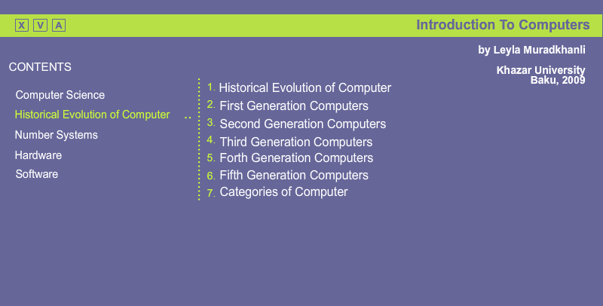

3.3 Main buttons
On using a programming language Action Script 2.0, Button was used to create links to each of the components.
In Flash there are buttons specially adapted for the function. It has 4 frames: Up, Over, Down, Hit, which contain the following state of the buttons:
- Up - the usual state of a button.
- Over - when the mouse is over the button.
- Down - when the cursor is over the button and mouse key is pressed.
- Hit - the usual state for a button that contains the link, the user has already visited.
/* buttons menu*/
comp_green._visible = false;
history_green._visible = false;
numb_green._visible = false;
hard_green._visible = false;
soft_green._visible = false;
wind_green._visible = false;
comp.onPress = function() {
gotoAndStop("Comp");
//unloadMovieNum(20);
comp._visible = false;
comp_green._visible = true;
history_green._visible = false;
numb_green._visible = false;
hard_green._visible = false;
soft_green._visible = false;
wind_green._visible = false;
history._visible = true;
numb._visible = true;
hard._visible = true;
soft._visible = true;
wind._visible = true;
};
history.onPress = function() {
gotoAndStop("History");
//unloadMovieNum(20);
history._visible = false;
history_green._visible = true;
comp_green._visible = false;
numb_green._visible = false;
hard_green._visible = false;
soft_green._visible = false;
wind_green._visible = false;
comp._visible = true;
numb._visible = true;
hard._visible = true;
soft._visible = true;
wind._visible = true;
};
numb.onPress = function() {
gotoAndStop("Numb");
//unloadMovieNum(20);
numb._visible = false;
numb_green._visible = true;
comp_green._visible = false;
history_green._visible = false;
hard_green._visible = false;
soft_green._visible = false;
wind_green._visible = false;
comp._visible = true;
history._visible = true;
hard._visible = true;
soft._visible = true;
wind._visible = true; };
hard.onPress = function() {
gotoAndStop("Hard");
//unloadMovieNum(20);
hard._visible = false;
hard_green._visible = true;
comp_green._visible = false;
history_green._visible = false;
numb_green._visible = false;
soft_green._visible = false;
wind_green._visible = false;
comp._visible = true;
history._visible = true;
numb._visible = true;
soft._visible = true;
wind._visible = true; };
soft.onPress = function() {
gotoAndStop("Soft");
//unloadMovieNum(20);
soft._visible = false;
soft_green._visible = true;
comp_green._visible = false;
history_green._visible = false;
numb_green._visible = false;
hard_green._visible = false;
wind_green._visible = false;
comp._visible = true;
history._visible = true;
numb._visible = true;
hard._visible = true;
wind._visible = true; };
wind.onPress = function() {
gotoAndStop("Wind");
//unloadMovieNum(20);
wind._visible = false;
wind_green._visible = true;
comp_green._visible = false;
history_green._visible = false;
numb_green._visible = false;
hard_green._visible = false;
soft_green._visible = false;
comp._visible = true;
history._visible = true;
numb._visible = true;
hard._visible = true;
soft._visible = true; };
Simple code with booting was used in submenu.
on (press) {

loadMovieNum("Anim_4-2.swf", 19);
}
Where *. swf each animation separately. A frame with the number of topics was created for each lesson in the submenu.
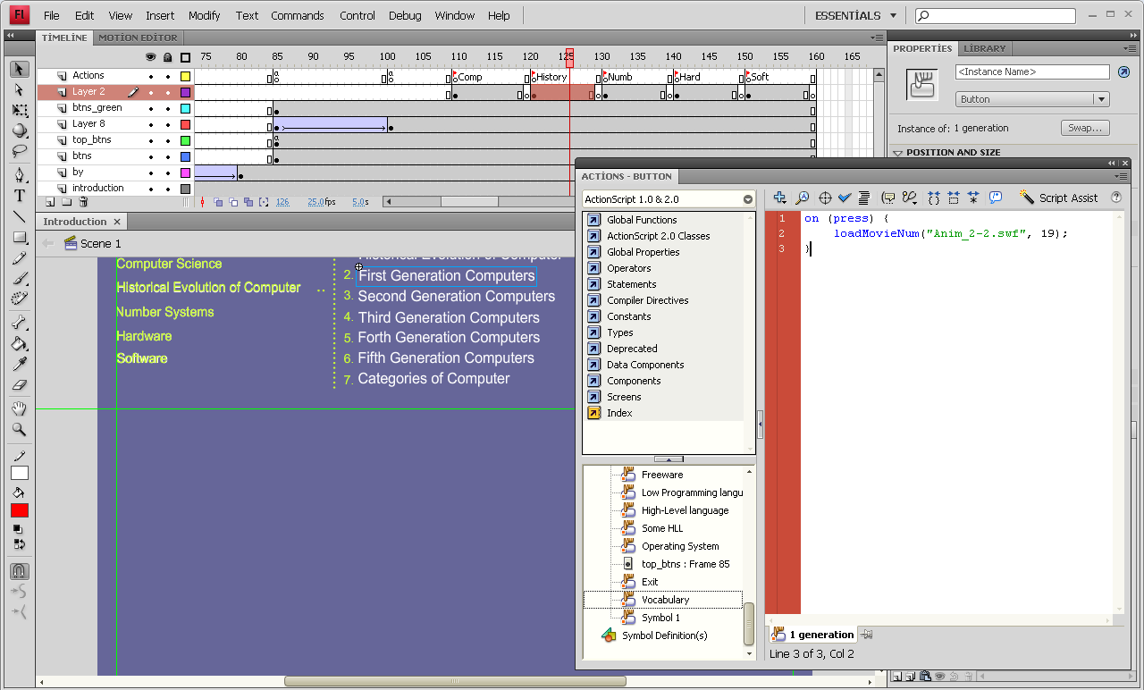
3.4 Dictinary
Following the creation of the so-called skeleton of the product, two very imperative tasks were reviewed. The first task is to create a dictionary. Considering that the education in our university is in English, it is very important to have the dictionary. It was decided to make a mobile dictionary, which might optionally be dragged over void corner of the screen.
on (press) {
this.startDrag(); }
on (release) {
this.stopDrag(); }
on (rollOver) {
_level0.justWordCaled = false; }
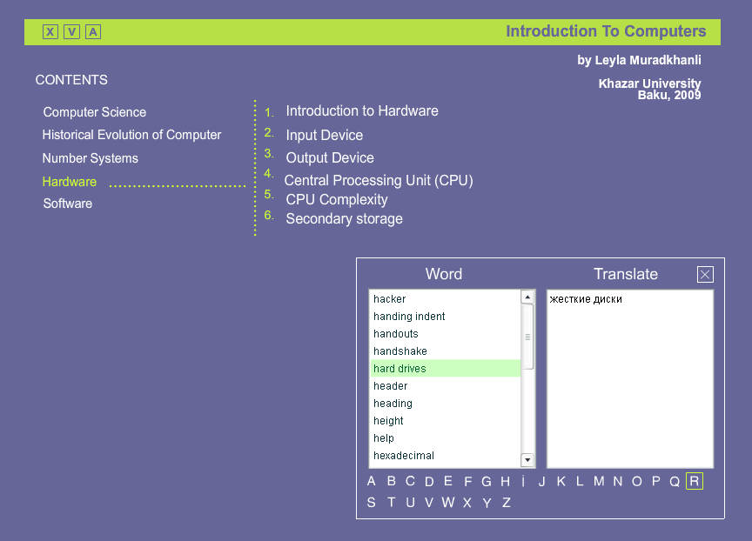
List of words appears while pressing each letter
alabel = new Array('Abort', 'access', 'accessibility options', 'accessories', 'active channel', 'active technology', 'add', 'add printer', 'advance', 'after', 'airbrush', 'align', 'alignment', 'all', 'allow', 'amount', 'amplification', 'angle', 'annotations', 'answer wizard', 'appearance', 'application', 'application suite', 'apply', 'approximate', 'arrange', 'arrange jcons', 'arrow', 'article', 'article', 'artificial', 'assemble', 'assortment', 'attract', 'auditing', 'auto arrange', 'auto correct', 'auto dialer', 'auto fill', 'auto save', 'auto shape', 'auto sort', 'auto sum', 'auto text', 'average' );
adata = new Array('Прервать выполнение программы', 'доступ', 'специальные возможности', 'стандартные', 'активный канал', 'технология', 'добавить', 'установка принтера', 'прогресс', 'после', 'аэрограф', 'выравнивать', 'выравнивание', 'весь, все', 'позволить', 'количество', 'усиление, увеличение', 'градус', 'аннотация', 'мастер ответов', 'проявление', 'приложение', 'пакет прикладных программ', 'применить (зафиксировать)', 'приблизительный, приближение, аппроксимация', 'упорядочить', 'упорядочить значки', 'стрелка', 'статья', 'изобретение', 'искусственный', 'собраться', 'ассортимент', 'привлечь', 'зависимости', 'автоматически', 'авто замена', 'авто набор', 'авто заполнение', 'авто сохранения', 'авто форма', 'авто сортировка', 'авто суммирования', 'авто текст', 'среднее');
//*******************************************************************
blabel = new Array( 'background', 'backup', 'banner ', 'bar', 'bar charts', 'bay', 'beads', 'binary', 'binder', 'bit', 'black', 'black and white', 'board', 'bold', 'bookmark', 'border', 'borders', 'bottom', 'break', 'brief', 'briefcase', 'browse', 'browser', 'bug', 'bullet', 'bulleted', 'list', 'bus', 'button');
bdata = new Array( 'фон', 'резервный', 'флажок', 'лента', 'полоса, строка, панель и брусок', 'линейные диаграммы', 'ванночка для дисководов, залив', 'нанизывать, фишка (на', 'счетах)', 'двоичный', 'подшивка', 'бит, кусок', 'черный', 'черно-белый', 'доска', 'размашистый(жирный)', 'закладка', 'граница, рамка', 'обрамление', 'низ', 'разрыв', 'краткий', 'портфель', 'обзор', 'обзор, посмотреть, пролистать', 'браузер', 'электронный жучок', 'символ списка, маркер', 'маркированный список', 'шина', 'кнопка' );
//*******************************************************************
clabel = new Array( 'cache', 'calculator', 'calendar', 'callout', 'cancel', 'capacity', 'caption', 'cascade', 'cell', 'change', 'chapter', 'character formatting', 'chart', 'chart wizard', 'chat', 'check', 'check box', 'check button', 'choose', 'circuit', 'clear', 'click', 'client application', 'client program', ' clipboard ', 'clipboard viewer', 'clock', 'close' , 'close button ', 'coated', 'color', 'column', 'column charts', 'command line', 'comment', 'compare', 'compile', 'compress', 'comprised', 'computer addiction ', 'computer and internet dependency ', 'connection ', 'consist ', 'constrain keys ', 'consumption ', 'contents ', 'continue ', 'control ', 'control panel ', 'cookie ', 'copy ', 'cord ', 'cordless ', 'corner ', 'correspondents ', 'crash ', 'create ', 'create shortcut ', 'crop picture ', 'cue ', 'cards ', 'cursor ', 'custom ', 'customize ', 'cut ', 'cyan ', 'cyberpunk ', 'cyberspace ', 'cycle ');
cdata = new Array('кеш, тайник, наличность', 'калькулятор', 'календарь', 'выноска', 'отменить', 'емкость', 'заголовок, название', 'каскада', 'ячейка', 'заменить', 'глава', 'знак, характер', 'форматирование на уровне символов', 'диаграмма', 'мастер диаграмм', 'чат (дружеская беседа)', 'проверка(чек), отметить', 'флажок', 'переключатель, флажок', 'выбрать', 'цикл', 'очистить', 'щелкнуть', 'клиентское приложение', 'клиентская программа', 'буфер обмена', 'просмотр буфера обмена', 'часы', 'закрыть', 'кнопка закрытия', 'покрытый', 'цвет', 'столбец, колонка', 'столбчатые диаграммы', 'командная строка', 'комментарий', 'сравнить', 'компилировать', 'сжимать, архивировать', 'включенный', 'компьютерная наркомания', 'компьютерная-интернет зависимость', 'соединение', 'состоит', 'модифицирующие клавиши', 'потребление', 'содержание', 'продолжать', 'управлять', '', 'панель управление', 'куки', 'копировать', 'шнур', 'безпересной, беспроводной', 'угол', 'корреспонденты', 'сбой(крах)', 'создать', 'создать ярлык', 'урезать рисунок', 'карта пошаговых инструкций', 'курсор, маркер', 'порядок, традиции', 'настроить', 'вырезать', 'синий', 'киперпанк', 'кибер-пространство', 'цикл');
//*******************************************************************
dlabel = new Array('damage', 'dash', 'dashed', 'data cashing', 'database', 'date', 'debugging', 'decrease', 'default', 'define', 'delete', 'demote', 'design view', 'desktop', 'desktop case', 'destination', 'document', 'detail data', 'details', 'determine', 'deviation', 'device', 'dial', 'dial-up remote access', 'dialog-boxes', 'different', 'digit', 'directory', 'distinct', 'distribution', 'document', 'domain', 'domain name system', 'dot', 'doughnut charts', 'down', 'download', 'draft', 'drag', 'drag and drop', 'dragging', 'draw', 'drill', 'down', 'drive', 'drop cap', 'drop-down list box', 'dye' );
ddata = new Array('повреждение', 'тире', 'пунктир', 'кэширование данных', 'база', 'данных', 'дата', 'отладка', 'уменьшение', 'по умолчанию', 'определить', 'удалить', 'понизить в иерархии', 'режим конструктора', 'рабочий стол', 'лежащий процессорный блок', 'адресат', 'документ приемник', 'структуризация данных', 'состав в таблицы', 'определить', 'деление', 'устройство', 'циферблат, настраивать', 'удаленный доступ через коммутируемую линию', 'окно диалога', 'различный', 'цифра', 'каталог, директория', 'отличный', 'распределение', 'документ', 'домен, территория, сфера', 'доменная система имен', 'точка', 'кольцевые диаграммы', 'вниз', 'пересылать, загружать', 'загрузка', 'проект, черновой', 'переместить', 'перетащить и отпустить', 'протаскивание', 'рисовать', 'временно отложить', 'дисковод, логический диск', 'буквица', 'раскрывающийся список', 'окрасить');
//*******************************************************************
elabel = new Array('echo', 'edge', 'edit', 'efficiency', 'efficiency drive', 'eliminate', 'e-mail', 'embedding', 'emptying recycle bin', 'encoding', 'endnote', 'engine', 'enter', 'entertainment', 'equal', 'equipment', 'erase', 'error', 'escape', 'Ethernet', 'even', 'event', 'excel', 'executable', 'execute', 'execution', 'exist', 'existence', 'exit', 'expand', 'expansion card', 'explorer', 'extension');
edata = new Array('эхо', 'край', 'редактировать', 'коэффициент полезного действия', 'рационализаторство', 'исключать', 'электронная почта', 'внедрение', 'очистка корзины', 'кодировка текстовой информации', 'примечание', 'двигатель', 'ввести, войти', 'развлечение', 'равно', 'оборудование', 'стереть, уничтожить', 'ошибка', 'убежать, отменить', 'локальная сеть', 'даже', 'случай', 'превосходить', 'выполнимый', 'выполнить', 'выполнение', 'существовать', 'существование', 'выход', 'развиваться, излагать, расширяться', 'плата', 'проводник', 'расширение' );
//*******************************************************************
flabel = new Array('failure', 'false', 'FAQ (frequently asked question', 'fast', 'favorites', 'feature', 'fee', 'field', 'file', 'ilt', 'filter', 'find', 'finish', 'firewall', 'flame', 'flatbed', 'flexible', 'floppy', 'folder', 'font', 'font name', 'font size', 'font style', 'footer', 'footnote', 'foreground', 'form view', 'format painter', 'formatting', 'forward', 'foundation', 'frame', 'freeware', 'freeze pane', 'FTP (File Transfer Protocol)', 'full screen', 'fully', 'future');
fdata = new Array('неудачный', 'ложь', 'чаво (часто задаваемые вопросы и ответы) ', 'быстрый', 'избранное', 'особенность', 'вознаграждение, плата, нанимать', 'поле', 'файл', 'заливка', 'фильтр', 'найти (поиск)', 'конец, готово', 'брандмаузер', 'пламя', 'планшетный', 'гибкий', 'гибкий, эластичный', 'папка', 'шрифт', 'имя шрифта', 'размер шрифта', 'стиль шрифта', 'нижний колонтитул', 'сноска', 'передний план', 'режим формы', 'формат по образцу', 'форматирование', 'вперед', 'основа', 'рамка(КАДР)', 'бесплатные программы', 'фиксированная область', 'протокол передачи файлов', 'во весь экран', 'полностью', 'будущее');
//*******************************************************************
glabel = new Array( 'game', 'gamer', 'gateway', 'gesture', 'get', 'GIF (Graphic Interchange Format)', 'glare filter', 'go to', 'goal seek', 'graphical data formats', 'grid', 'group', 'group/ungroup', 'guide', 'gutter');
gdata = new Array('игра', 'геймер', 'шлюз(ворота)', 'жест', 'получить', 'формат графического обмена', 'защитный экран', 'перейти к', 'подбор параметров', 'форматы графических данных', 'сетка', 'группа', 'сгруппировать/рас группировать', 'направляющий (гид)', 'полоса переплета, желоб');
//*******************************************************************
hlabel = new Array('hacker', 'handing indent', 'handouts', 'handshake', 'hard drives', 'header', 'heading', 'height', 'help', 'hexadecimal', 'hidden slide', 'hide', 'highlight', 'hit', 'hold', 'homepage', 'host', 'hot keys', 'hourglass', 'household', 'HTML (Hypertext Markup Language)', 'HTTP (Hypertext Transfer Protocol)', 'Hyperlinks', 'Hypertext');
hdata = new Array('хакер', 'весящий отступ, выступ', 'раздаточный материал', 'рукопожатие', 'жесткие диски', 'верхний колонтитул', 'заголовок', 'высота', 'помощь (справка)', 'шестнадцатеричный', 'скрытый слайд', 'спрятать', 'выделение цветом', 'нажать', 'держать', 'домашняя страница', 'главный компьютер', 'горящие клавиши', 'песочные часы', 'бытовой', 'язык гипертекстовой разметки', 'протокол передачи гипертекста', 'гипперссылки', 'гипертекст');
//*******************************************************************
ilabel = new Array('icon', 'icon label', 'image', 'improve', 'inbox', 'increase', 'indent', 'index', 'index', 'information security', 'inscribe', 'insert', 'inside', 'install', 'integrated circuit', 'inter', 'internet', 'interpreter', 'interrupt', 'intranet', 'IQ (Intelligence Quotient)', 'italic', 'item');
idata = new Array('пиктограмма(значок)', 'метка', 'изображение, образ', 'улучшать', 'входящие', 'увлечение', 'отступ', 'индекс', 'указать, указатель', 'безопасность информации', 'надписать', 'вставка, вставить', 'внутри', 'установка', 'интегральная схема', 'между, среди', 'интернет', 'интерпретатор', 'прервать', 'интранет', 'коэффициент умственных способностей', 'курсив', 'элемент, пункт');
//*******************************************************************
jlabel = new Array('jet', 'justify');
jdata = new Array('струя, впрыскивать', 'выровнять по ширине');
//******************************************************************
klabel = new Array('key', 'keyboard shortcuts');
kdata = new Array('клавиша или ключ (в базах данных)', 'быстрые клавиши');
//*******************************************************************
qlabel = new Array('');
qdata = new Array('');
//*******************************************************************
llabel = new Array('LAN (Local Area Network)', 'landscape', 'large icons', 'layout', 'leased line remote access', 'left', 'legend', 'length', 'letter', 'line', 'line charts', 'link', 'list', 'list box', 'list delete', 'local disk', 'local printer', 'location', 'log off', 'login name', 'loop');
ldata = new Array('локальные компьютерные сети', 'горизонтальный, альбомный', 'большие значки', 'разметка', 'удаленный доступ по выделенной линии', 'левый', 'легенда', 'длина', 'буквы, письмо', 'строка', 'линейные графики', 'связать, связывать', 'список', 'список', 'удалить список', 'локальный диск', 'локальный принтер', 'местоположение', 'завершение сеанса', 'имя пользователя', 'цикл');
//*******************************************************************
mlabel = new Array('mach', 'macro', 'magenta', 'magnifier', 'mailer', 'mailing list', 'main', 'mainframe', 'make', 'manage', 'map of the site', 'margin', 'match', 'match case', 'matrix', 'maximize', 'maximize button', 'measurement', 'memory', 'menu', 'meny bar', 'merge', 'message', 'Microsoft Office Shortcut bar', 'milestones', 'minimize', 'minimize button', 'mirror', 'mode', 'modem', 'modify', 'motherboard', 'move', 'moving', 'MS-DOS prompt', 'My briefcase', 'my computer');
mdata = new Array('машина', 'макрос', 'сиреневый', 'увеличение', 'почтовая программа', 'список рассылки', 'главный', 'мэйнфрейм','сделать, создать', 'управлять', 'карта сервера', 'поля (край)', 'соответсвие, пара', 'учитывать регистр', 'матрица', 'развернуть', 'кнопки максимизации', 'измерение', 'память', 'меню', 'строка меню', 'слияние, объединение', 'сообщение', 'панель майкрософт оффис', 'вехи', 'свернуть', 'кнопка свертывания', 'зеркало', 'способ', 'модем', 'модифицировать, изменить', 'материнская плата', 'предвигать, преслать, переместить', 'перемещение', 'подсказка мсдос', 'портфель', 'мой компьютер');
//*******************************************************************
nlabel = new Array( 'name', 'Netware', 'network', 'network neighborhood', 'network printer', 'new', 'newsgroup', 'next ', 'no', 'node', 'none', 'normal', 'normal view');
ndata = new Array('имя', 'сетевые изделия (программы)', 'сеть', 'сетевое окружение', 'сетевой принтер', 'новый (создать)', 'группа новостей, телеконференция', 'далее', 'нет', 'узел', 'не один', 'обычный, нормальный', 'обычный режим просмотра');
//*******************************************************************
olabel = new Array('octal', 'odd', 'offer', 'offline', 'old', 'OLE (object Linking Embedding)', 'online', 'opaque', 'open back', 'option', 'option button', 'options', 'outline', 'outside', 'overwrite');
odata = new Array('восьмеричный', 'нечетный (странный)', 'предложение, попытка', 'автономный режим', 'старый', 'связывание и внедрение объектов', 'онлайновый режим', 'непрозрачный', 'открыть назад', 'режим, опция, параметр', 'переключать', 'параметры', 'контур, план, схема, структура', 'сснаружи', 'перезаписать');
//*******************************************************************
plabel = new Array('pad', 'page', 'page layout view', 'palette', 'paper', 'paragraph', 'paragraph marks', 'paragraph-level formatting', 'parents', 'particular', 'password', 'paste', 'paste special', 'path', 'pathway', 'pattern', 'peer', 'per', 'performance', 'peripheral', 'phase', 'pick', 'picture', 'pie charts', 'pieces ', 'pivot table', 'plug&play', 'point', 'point and click', 'pointer', 'pop-up', 'popup menu', 'port', 'portrait', 'power', 'power supply', 'PPP (Point to Point Protocol)', 'press', 'preview window', 'print', 'print preview', 'print screen', 'program item', 'programs', 'prompt', 'proof', 'properties', 'protect', 'provide', 'proxy', 'pull-down', 'punching card', 'pure', 'push', 'push-button', 'put');
pdata = new Array('коврик', 'страница', 'режим разметки страницы', 'палитра', 'бумага', 'абзац', 'маркер абзацев', 'форматирование на уровне абзацев', 'родительский, поражающей, над', 'специфический', 'пароль', 'приклеить(вставит)', 'специальная вставка', 'путь', 'тропа', 'узор', 'равный', 'в(на)', 'выполнение', 'периферия', 'фаза, стадия', 'преобразовать', 'рисунок, изображение, картинка', 'круговые диаграммы', 'части', 'сводная таблица', 'подключи и работай', 'указать и щелкнуть', 'курсор, маркер, позиция ввода', 'всплывающая (меню)', 'контекстное меню', 'порт', 'портретный, вертикальный, книжный', 'мощность, силовой', 'блок питания', 'новый протокол серийной передачи данных', 'нажать', 'образец, просмотр', 'окно предварительного просмотра', 'печатать', 'предварительный просмотр', 'выводить на экран', 'программная группа', 'программы', 'приглашение', 'стандартные', 'свойства', 'защита', 'обеспечить', 'полномочия', 'ниспадающая', 'перфокарта', 'чистый', 'нажать, толчок', 'командная кнопка', 'выдать, поместить');
//*******************************************************************
qlabel = new Array('QBE (Query by example)', 'quality', 'query', 'question mark pointer', 'quick view', 'quit');
qdata = new Array('запрос по образцу', 'качество', 'запрос', 'указатель мыши с вопросительным знаком', 'быстрый просмотр', 'выход');
//*******************************************************************
rlabel = new Array('radio button', 'random', 'range', 'raster', 'recognize', 'recolor picture', 'record', 'recycle bin', 'redo', 'refers', 'regular', 'rehears new timings', 'remove', 'rename', 'repair', 'replace', 'report', 'reset', 'resolution', 'restore', 'restore button', 'retrieval', 'retry', 'revolution', 'right', 'round', 'router', 'row', 'ruler', 'run');
rdata = new Array('поле выбора, радиокнопка', 'случайный', 'ранг, диапазон', 'растр', 'распознавание', 'перекрасить рисунок', 'запись', 'корзина', 'повторить операцию', 'обращается', 'обычный', 'репетиция доклада с использование хронометража', 'удалить', 'переименовать', 'ремонт', 'замещать', 'отчет', 'сбросить, восстановить, перезагрузить', 'разрешение', 'восстановить', 'кнопки восстановления', 'поиск, возвращение, исправление', 'повторить операцию', 'цикл, поворот', 'правый', 'вокруг', 'маршрутизатор', 'строка', 'линейка', 'выполнить');
//*******************************************************************
slabel = new Array('safe', 'safely', 'sample', 'save', 'save as', 'saved search', 'scale', 'schedule', 'screen', 'scribe', 'script', 'scroll', 'scroll bar', 'search', 'section', 'seldom', 'selet', 'select all', 'send to', 'separate', 'serve', 'server application', 'server program', 'service provider', 'serving', 'sessions', 'set', 'setting Microsoft network', 'settings', 'setup', 'sex', 'shade', 'shading', 'shadow', 'shape', 'share', 'sharing', 'sheets', 'shift', 'shortcut', 'shortcut menus', 'shut down', 'sign', 'size', 'skip', 'slave', 'sleep', 'slide master', 'slide show', 'slider', 'slides', 'slightly', 'SLIP (Serial Line Internet Protocol)', 'slot', 'slow', 'small icons', 'snap', 'solver', 'sorting', 'source document', 'spare', 'speaker', 'spelling', 'spider', 'spin box', 'spool file', 'spray', 'spreadsheets', 'start', 'start menu', 'startup', 'status', 'status bar', 'steam', 'stick', 'stiff', 'storage', 'strike', 'string', 'style', 'style gallery', 'stylus', 'sublimation', 'subscript', 'suggest', 'superconductor', 'superscript', 'supervision', 'supply', 'support', 'surface', 'surge', 'swap', 'switch', 'system tools');
sdata = new Array('сохраненный', 'безопасный', 'пример', 'сохранить', 'сохранить как', 'сохраненный поиск', 'масштаб', 'расписание', 'экран', 'писец, размечать', 'сценарий', 'прокрутка', 'полоса прокрутки', 'искать, поиск', 'раздел', 'редкий', 'выделить', 'выделить все', 'отправить', 'раздельный', 'обслуживать', 'серверное приложение', 'серверная программа', 'провайдер', 'серфинг', 'сессии', 'набор, аппарат, устанавливать', 'установка майкрософт нетверк', 'настройка', 'установка', 'пол', 'тень, оттенок', 'отцвет, блик', 'тень', 'фигура', 'ресурс', 'разделение', 'листы рабочий таблиц', 'скользить', 'ярлык', 'меню быстрого доступа или контекстное меню', 'завершение работы', 'знак', 'размер', 'пропустить', 'подчиненный винчестер (раб)', 'сон', 'шаблон слайдов', 'демонстрация слайдов', 'ползунок', 'слайды', 'слегка', 'протокол серийной передачи данных', 'щель', 'медленно', 'маленькие значки', 'привязать', 'подбор параметра', 'сортировка', 'документ, источник', 'резерв', 'колонки', 'орфография', 'паук', 'счетчик', 'буферный файл', 'распылить', 'электронные таблицы', 'пуск', 'главное меню', 'автозагрузка', 'статус', 'строкасостояния', 'пар, испарение, энергия', 'придерживаца (палка)', 'жесткий', 'хранение', 'нажать, ударить', 'строка', 'стиль', 'библиотека стилей', 'пишущий штифт', 'сублимация', 'нижний индекс', 'предлагать', 'сверхпроводник', 'верхний индекс', 'наблюдатель', 'поставка, обеспечение', 'поддержка', 'поверхность', 'натиск, толчок, колебание', 'перестановка', 'переключить', 'служебные программы');
//*******************************************************************
tlabel = new Array('tab', 'table', 'tabs', 'tale', 'task', 'taskbar', 'TCIP/IP (Transmission Control Protocol/Internet Protocol)', 'templates', 'temporary', 'text box', 'thermal', 'thesaurus', 'tile', 'tile windows horizontally', 'tile windows vertically', 'time', 'tip', 'tip wizard', 'title', 'title bar', 'toggle', 'tool', 'tool tip', 'toolbar', 'top', 'topics', 'tower', 'track', 'transfer', 'trash', 'tree', 'trouble chart', 'true', 'type', 'type size', 'type stile', 'typeface');
tdata = new Array('табуляция', 'таблица', 'вкладки, вкладыши', 'рассказ', 'задача', 'панель задач', 'протоколы передачи данных', 'шаблоны', 'временный', 'строка ввода', 'тепловой', 'тезаурус(синоним, антоним)', 'замостить', 'окна сверху вниз', 'окна слева направо', 'время', 'совет, намек', 'мастер подсказок', 'заголовок', 'строка заголовка', 'переключатель', 'сервиз, инструменты', 'подсказка', 'панель инструментов', 'верх', 'темы', 'башенный', 'дорожка, след', 'транспортировка', 'хлам', 'дерево', 'таблица неисправностей', '"истинный" шрифт генерируемый математическими формулами', 'набрать, напечатать', 'размер записи', 'стиль записи', 'вид шрифта');
//*******************************************************************
ulabel = new Array();
udata = new Array();
//*******************************************************************
uulabel = new Array('underline', 'undo', 'uninstall', 'unit', 'until', 'up', 'update', 'upgrade', 'uploading', 'URL (Uniform Resource Locator)', 'usage', 'Usenet', 'user');
uudata = new Array('подчеркивать', 'отменить', 'удаление', 'единица, устройство', 'до', 'вверх', 'обновление (файлов)', 'обновление', 'выгрузка, подкачка', 'универсальный указатель источника', 'точный адрес в интернете', 'использование', 'пользовательская сеть', 'пользователь');
//*******************************************************************
vlabel = new Array('vacuum tubes', 'vending machine', 'via', 'view', 'view buttons', 'viewer', 'viewing', 'voice data formats');
vdata = new Array('вакуумные трубки (лампы)', 'торговый автомат', 'через', 'вид, просмотр, просматривать', 'кнопки режимов просмотра', 'программы просмотра', 'просмотр', 'файлы звуковых данных');
//*******************************************************************wlabel = new Array('WAN (Wide Area Network)', 'ware', 'warm restart', 'wavy', 'wax', 'web', 'web help', 'web page', 'web search engines', 'web server', 'webmaster', 'welcome screen','what\'s this?', 'white','wide', 'widely', 'width', 'window', 'windows update', 'wire', 'word', 'word art', 'word count', 'word draw', 'workbook', 'workgroup', 'wrap', 'write', 'WWW (world wide web)');
wdata = new Array('глобальные компьютерные сети', 'изделия', 'перезагрузка из памяти', 'волнистый', 'воск', 'паутина', 'помощь в интернете', 'документ веб', 'поисковые механизмы веб', 'веб сервер', 'веб мастер', 'совет дня', 'что это такое?', 'Белый', 'широкий', 'широко, далекие (частоты)', 'ширина', 'окно', 'обновление виндоус', 'провод, проволока', 'слово', 'оформитель', 'подсчет слов', 'программа рисования', 'рабочая книга', 'рабочая группа', 'загибать, завернуть', 'писать', 'всемирная паутина');
//*******************************************************************
zlabel = new Array('zip', 'zoom', 'zoom in', 'zoom out');
zdata = new Array('почтовый индекс', 'масштаб', 'приблизить, свернуть', 'отодвинуть, распахнуть');
//********************************
//dlya lugeta
exit_btn.onPress = function() {
unloadMovieNum(20);
};
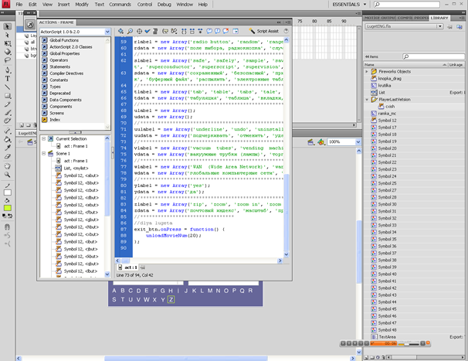

3.5 Animation
The second task was within animation. The button Stop \ Play was needed. At any time a student could stop watch and record the necessary facts for himself. The component of Movie Clip was used here again, in which the button itself and the code were painted. Animation (movie clip) is the "full" type of character. Any number of frames might be available within it. The symbol of this type can be perceived as an object of Movie in ActionScript type (this embedded language is Flash).
Regardless of the type, characters can be nested. It is the most important advantage of them. For example, you can make a button that will move when the "fly" mouse pointer is above it, just put in the frame Over symbol - animation. Or put a running cat on the image. Symbols can be created as a "from scratch" (Insert-> New Symbol, Ctrl + F8), or by using the current selection, placing it directly into a symbol (Insert-> Convert to Symbol, F8). The second method is used much more frequently than the first, because in this case there is no need to position and change it upon desired size.
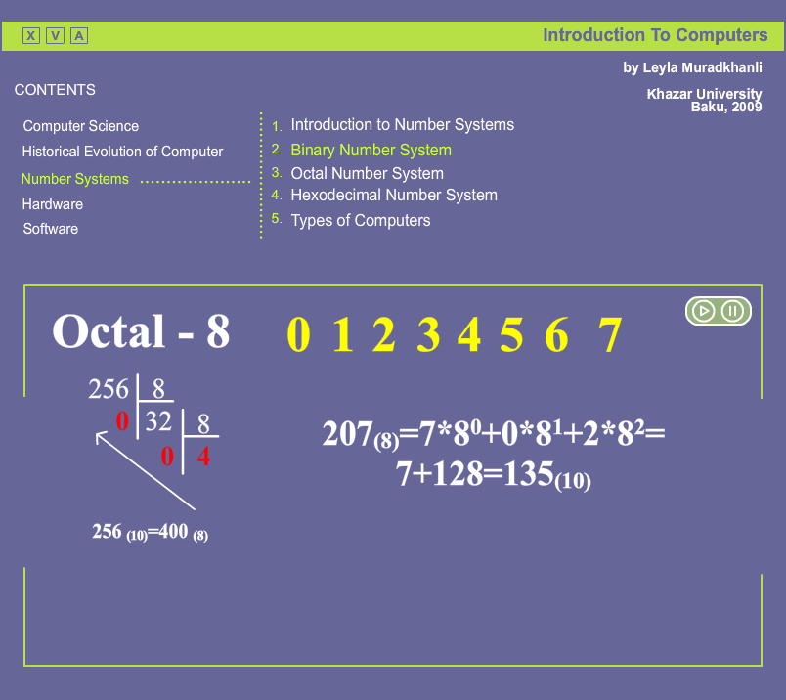
The so-called library (Library) is used to control the symbols Window Library is located at Window-> Library (or Ctrl-L).
var thisScope = this;
var ifPaused = false;
playPauseBtn.onPress = function(){
if(ifPaused){ thisScope.play();
ifPaused = false;
}else{ thisScope.stop();
ifPaused = true; }}
Second task has been solved thereby.
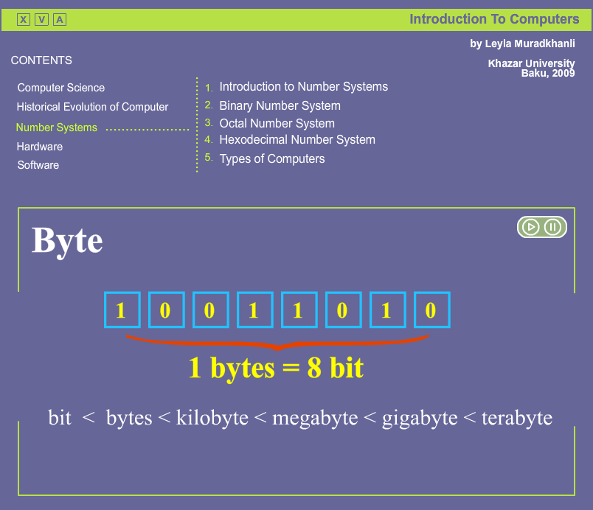
Layers are always used in the creation of animation. In computer graphics, this tool is used very frequently. Layers can be made invisible and / or inaccessible, to facilitate the editing of the scene in general.
There are several special types of layers in Flash: layers containing the trajectory of motion and layer mask. There are quite a number of devices using layers, but you just cannot do without them in Flash for one important reason: each animation object requires a separate layer at one time. Each line of frames belongs to a particular layer.
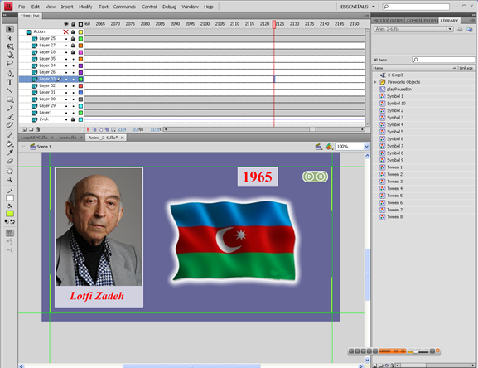
Related to location layer of object, it would be seen in the foreground, or be behind other objects. Using layers, you can easily create a sense of multidimensional scene.
The layers can not only be carriers of line staff: guiding layers serve for definition of path and animation parameters, masking layers allow to specify a mask, limiting the visible part of the image of subordinate layers, button layers describe the state-sensitive mouse clicks areas.
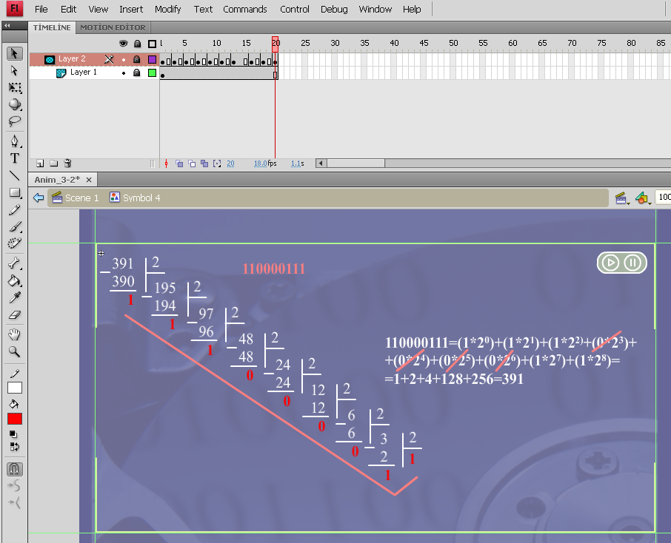
Frames. Animation consists of a sequence of frames. Frame can be either compiled manually or generated by Flash. This applies to frames of one layer. Since Flash scenes usually consist of several layers, then wrap-up "multilayer" frames can contain both generated and "homemade" layers.
There is a concept in computer animation - key frames (key frames) which are not allowed to be changed by Flash in the process of creating animation. Key frames are set, while intermediate ones between them develop Flash. There are two types of intermediate frames: frames generated on the basis of changes in the geometry (shape tween) or frames, built on the changing character (motion tween). And, of course, frames might be empty.
By frame animation – this type of animation is entirely composed of key frames, thus, the user determines the contents of the frame, and its "duration" (i.e. how many static frames the image will occupy)
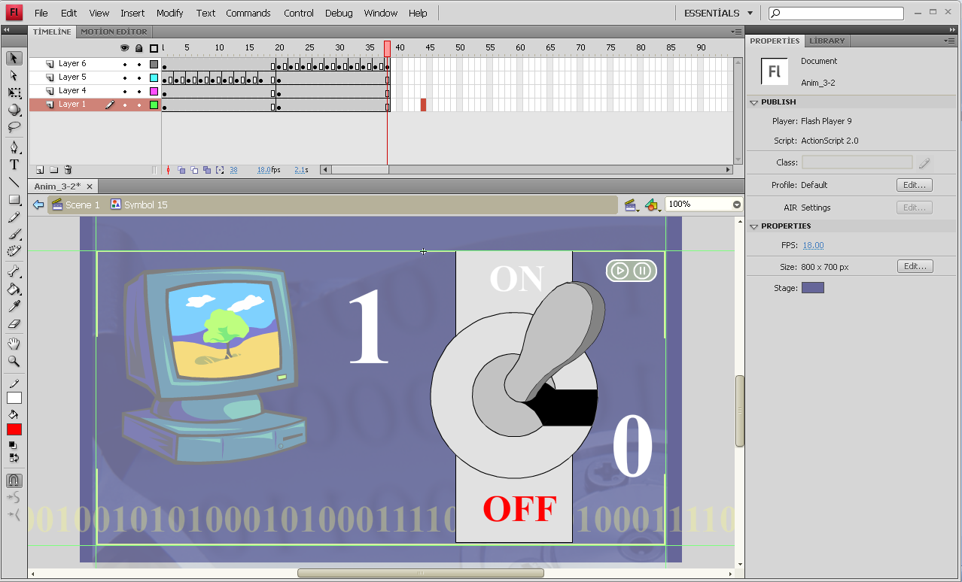
3.6 Video.
The Adobe Flash Player is software for viewing animations and movies using computer programs such as a web browser. Flash player is a widely distributed proprietary multimedia and application player created by Macromedia and now developed and distributed by Adobe after its acquisition. Flash Player runs SWF files that can be created by the Adobe Flash authoring tool, by Adobe Flex or by a number of other Macromedia and third party tools.
Adobe Flash, or simply Flash, refers to both a multimedia authoring program and the Adobe Flash Player, written and distributed by Adobe, that uses vector and raster graphics, a native scripting language called ActionScript and bidirectional streaming of video and audio. Strictly speaking, Adobe Flash is the authoring environment and Flash Player is the virtual machine used to run the Flash files, but in colloquial language these have become mixed: "Flash" can mean either the authoring environment, the player, or the application files.
Flash Player has support for an embedded scripting language called ActionScript (AS), which is based on ECMAScript. Since its inception, ActionScript has matured from a script syntax without variables to one that supports object-oriented code, and may now be compared in capability to JavaScript (another ECMAScript-based scripting language).
The Flash Player was originally designed to display 2-dimensional vector animation, but has since become suitable for creating rich Internet applications and streaming video and audio. It uses vector graphics to minimize file size and create files that save bandwidth and loading time. Flash is a common format for games, animations, and GUIs embedded into web pages.
The Flash Player is available as a plugin for recent versions of web browsers (such as Mozilla Firefox, Opera, Safari and Internet Explorer) on selected platforms. Adobe states that each version of the plugin is backwards-compatible, with the exception of security changes introduced in Version 10.
var thisScope = this;
var activeButton = null;
m_1.onPress = function(){
activeButton.gotoAndStop(1);
this.gotoAndStop(2);
activeButton = this;
}
m_2.onPress = function(){
activeButton.gotoAndStop(1);
this.gotoAndStop(2);
activeButton = this;
}
m_3.onPress = function(){
activeButton.gotoAndStop(1);
this.gotoAndStop(2);
activeButton = this;
}

m_4.onPress = function(){
activeButton.gotoAndStop(1);
this.gotoAndStop(2);
activeButton = this;
}
m_5.onPress = function(){
activeButton.gotoAndStop(1);
this.gotoAndStop(2);
activeButton = this;
}
m_6.onPress = function(){
activeButton.gotoAndStop(1);
this.gotoAndStop(2);
activeButton = this;
}
m_7.onPress = function(){
activeButton.gotoAndStop(1);
this.gotoAndStop(2);
activeButton = this;
}
m_8.onPress = function(){
activeButton.gotoAndStop(1);
this.gotoAndStop(2);
activeButton = this;
}
m_9.onPress = function(){
activeButton.gotoAndStop(1);
this.gotoAndStop(2);
activeButton = this;
}
m_10.onPress = function(){
activeButton.gotoAndStop(1);
this.gotoAndStop(2);
activeButton = this;
}
for (var i = 1; i<11; i++) {
var m = thisScope["m_"+i];
trace(m)
m.onRollOver = function() {
this.gotoAndStop(3);
}; (all button change color when mous is on)
m.onRollOut = function() {
if (activeButton == this) {
this.gotoAndStop(2);
} else {this.gotoAndStop(1);
} }; }
m_1.onPress=function (){
gotoAndPlay(2);
stop();}
m_2.onPress=function (){
gotoAndPlay(3);
stop();}
m_3.onPress=function (){
gotoAndPlay(4);
stop();}
m_4.onPress=function (){
gotoAndPlay(5);
stop();}
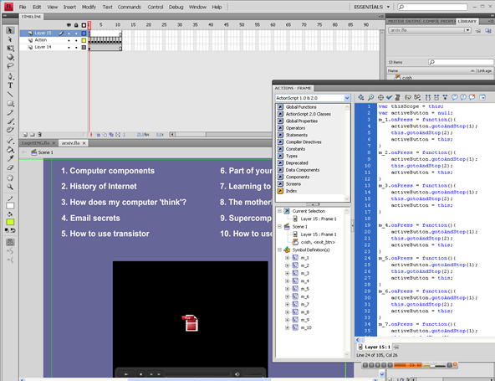
m_5.onPress=function (){
gotoAndPlay(6);
stop();}
m_6.onPress=function (){
gotoAndPlay(7);
stop();}
m_7.onPress=function (){
gotoAndPlay(8);
stop();}
m_8.onPress=function (){
gotoAndPlay(9);
stop();}
m_9.onPress=function (){
gotoAndPlay(10);
stop();}
m_10.onPress=function (){
gotoAndPlay(11);
stop();}

3.4 SWF
And finally specify publish settings for SWF files:
Select File > Publish Settings, click the Flash tab, and select a Player version from the Player pop-up menu. Not all Adobe® Flash® CS4 Professional features work in published SWF files that target Flash Player versions earlier than Flash Player 10. To specify Flash Player detection, click the HTML tab and select Detect Flash Version and enter Flash Player version to detect.
Select the Action Script version from the Script popup menu. If you select Action Script 2.0 or 3.0 and you’ve created classes, click Settings to set the relative class path to class files that differ from the path to default directories set in Preferences.
To control bitmap compression, adjust the JPEG Quality slider or enter a value. Lower image quality produces smaller files; higher image quality produces larger files. Try different settings to determine the best trade-off between size and quality; 100 provides the highest quality and least compression.
To make highly compressed JPEG images look smoother, select Enable JPEG Deblocking. This option reduces typical artefacts resulting from JPEG compression, such as the common appearance of 8x8-pixel blocking of the image. Some JPEG images may lose a small amount of detail when this option is selected.
To set the sample rate and compression for all streaming sounds or event sounds in the SWF file, click Set next to Audio Stream or Audio Event and select options as needed.
Note: A streaming sound plays as soon as enough data for the first few frames downloads; it is synchronized to the Timeline. An event sound does not play until it downloads completely, and it continues to play until explicitly stopped.
To override settings for individual sounds specified in the Sound section of the Property inspector, select Override Sound Settings. To create a smaller, low-fidelity version of a SWF file, select this option.
Note: If the Select Override Sound Settings option is deselected, Flash scans all stream sounds in the document (including sounds in imported video) and publishes all stream sounds at the highest individual setting. This can increase file size if one or more stream sounds has a high export setting.
To export sounds suitable for devices, including mobile devices, instead of the original library sound, select Export Device Sounds. Click OK.
To set SWF settings, select any of the following options:
Compress Movie (Default) Compresses the SWF file to reduce file size and download time. Most beneficial when a file is text- or ActionScript-intensive. A compressed file plays only in Flash Player 6 or later.
Include Hidden Layers (Default) Exports all hidden layers in the Flash document. Deselecting Export Hidden Layers prevents all layers (including layers nested inside movie clips) marked as hidden from being exported in the resulting SWF. This lets you easily test different versions of Flash documents by making layers invisible.
Include XMP metadata (Default) Exports all metadata entered in the File Info dialog box. Click the File Info button to open the dialog box. You can also open the File Info dialog box by choosing File > File Info. The metadata is viewable when the SWF file is selected in Adobe® Bridge.
Export SWC Exports a .swc file, which is used for distributing components. The .swc file contains a compiled clip, the component's ActionScript class file, and other files that describe the component.
To use advanced settings or enable debugging of the published Flash SWF file, select any of the following options:
Generate Size Report Generates a report listing the amount of data in the final Flash content by file.Protect From Import Prevents others from importing a SWF file and converting it back into a FLA document. Lets you use password protection with your Flash SWF file. Omit Trace Actions Causes Flash to ignore ActionScript trace statements in the current SWF file. When you select this option, information from trace statements does not appear in the Output panel. For more information, see Output panel overview. Permit Debugging Activates the Debugger and allows remote debugging of a Flash SWF file. Lets you use password protection with your SWF file.
If you are using ActionScript 2.0, and selected either Permit Debugging or Protect From Import, enter a password in the Password text field. If you add a password, other users must enter the password before they can debug or import the SWF file. To remove the password, clear the Password text field. For more information on the Debugger, see Debugging ActionScript 1.0 and 2.0. If you are using ActionScript 3.0, see Debugging ActionScript 3.0.
Select the Flash security model to use from the Local Playback Security pop-up menu. Specify whether to grant your published SWF file local or network security access. Local Access Only lets the published SWF file interact with files and resources on the local system but not on the network. Access Network Only lets the published SWF file interact with files and resources on the network but not on the local system.
To enable the SWF file to use hardware acceleration, select one of the following options from the Hardware Acceleration menu:
Level 1 - Direct Direct mode improves playback performance by allowing Flash Player to draw directly on the screen instead of letting the browser do the drawing.
Level 2 - GPU In GPU mode, Flash Player utilizes the available computing power of the graphics card to perform video playback and compositing of layered graphics. This provides another level of performance benefit depending on the user's graphics hardware. Use this option when you expect that your audience will have high-end graphics cards.
If the playback system does not have sufficient hardware to enable acceleration, Flash Player reverts to normal drawing mode automatically. For best performance on web pages containing multiple SWF files, enable hardware acceleration for only one of the SWF files. Hardware acceleration is not used in Test Movie mode.
When you publish your SWF file, the HTML file that embeds it contains a wmode HTML parameter. Choosing Level 1 or Level 2 hardware acceleration sets the wmode HTML parameter to "direct" or "gpu" respectively. Turning on hardware acceleration overrides the Window Mode setting you may have chosen in the HTML tab of the Publish Settings dialog box, because it is also stored in the wmode parameter in the HTML file.
To set a maximum time that scripts can take to execute in the SWF file, enter a value for the Script Time Limit. Flash Player cancels execution of any scripts that exceed the limit.

3.8 Working with sound
Once the movie was "great mute". People came to the movies to watch on a tiny screen, black and white pictures bouncing to the music of ragtime piano. It was a novelty as the first aircraft plywood, and the first phones, which had to be screaming with laughter, as well as four parallel lines shown on the screen first TV. All this was a miracle, inaccessible to the understanding of the broad masses, but because - is doubly appealing.
Now cinema has ceased to be a miracle, as well as air services, telephony and television. The miracle turned into a business, and what could be more prosaic. People talk on cellphones, fly on airplanes, at home watching TV and movies so that talk about it - cinemas almost dying.Nobody wants to go to the cinema: it has replaced the home video, VideoCD, DVD and DivX.(Say, in the capitals of the situation better than in the province, but who knows.) There will come a day when the miracle dies completely, replaced by what?
The only thing that will never die - is the magic of film. The magic of black and white jumping of those long ago no longer with us ...
Once the computers were big and slow, but could only convert one punch cards or punched tape in the other are the same punch cards or punched tape. Nobody in my thoughts could not admit that decades from their distant descendants will become a playground for the jaded townsfolk and their children. How - such a large and complicated equipment was funded by the military, and foremost was painted for the week ahead, what other toys?!
But years passed, and computers were really toys. In fact, if the home has a computer, make sure you can find and a CD with toys and movies (unless, of course, a computer powerful enough, and the owner - not a complete workaholic). Moreover, often the computer is only used for gaming and watching movies. Of course, the owner is trying to do something useful for his "iron friend", but the desire has not translated into reality.
Once the Internet was entirely text-based, dilute rare disseminations clumsy drawings. In those days, a worldwide network used, primarily, only scientists, military and government officials, and that really need these biscuits designer delights? The first Internet-quite enough textual information and files, none of them in a nightmare he could not foresee what will be used by the Network in ten years. How is it possible during the pumping music or watch online video, when you have the same tree-stick work - the work of the treasury pays the money, but not for music and video.
Now what's to tell about it - yourself go to the Web or even remember why you went there last time! Even if you were in my thoughts and find something truly for the cause, you will not forget about entertainment. And what fun is most accessible to the ordinary internet user? Of course, music. (Unfortunately, the video can only watch holders sufficiently fast channels, which are still little. But with time preferences of the majority may change.)
History repeats itself. And the cinema, and computers and the Internet from the "great mute" turned into "great talkers".
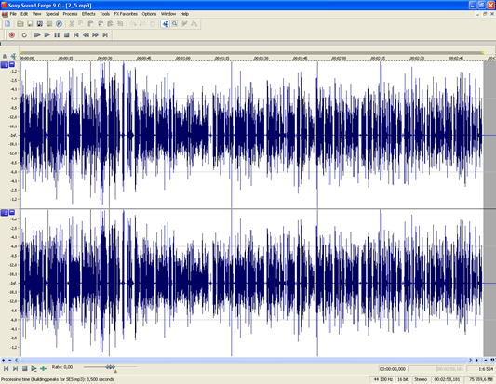
Encoding and storage of audio data. To encode audio and recording it in a file used three different ways. All of these methods, we now briefly consider. The first way - encode and write to file proper sound. In this case connects to a computer microphone or other audio source and the signal from it using special programs written to the file. This method of sound recording used in the vast majority of cases. For example, the popular formats WAV, MP3, VQF, WMA - all formats store audio data.
The advantage of this approach to the storage of sound is an exact reproduction of it on any device. For example, you can rewrite W format MRZ favorite cassettes, and your account will normally played on any computer or portable MRZ-player, though, of course, with different quality. Also, advantages are the ability to record any sounds (voices, natural and artificial noises, any musical instruments) and ease of processing (noise reduction, normalization, etc.).Disadvantage, perhaps, one: a large volume of the resulting record audio data array.
To reduce the array of audio data, using various compression algorithms. This can be as lossless compression and lossy. Typically, lossless compress the sound, intended for further processing and the losses - for distribution (for example, a well-known format MRZ). Sometimes the sound does not compress at all.
Coding and recording of sound - the most common way to store audio data. In particular, he used to distribute music on compact discs and files. The CD-ROM is recorded uncompressed audio, for distribution in the file use different compression algorithms. Also, this method of recording sound to create a soundtrack to video clips.
The second method - storage in files only teams to play sound. When I play these files, these commands are read and executed by a special program player or a properly equipped computer sound card. To create these files using special software or music synthesizers, again in conjunction with special programs.
To play the actual sound file players and sound cards are examples of playing real instruments or various real or synthesized sounds, called tools or samples. For the convenience of uploading and management tools are combined into banks instruments. Some very old programs, and sound cards are used for audio output method of frequency synthesis, but the quality of the sound is very bad.
The advantage of the second method is the compactness of the resulting files. In fact, to record a couple of bytes that make up the team, a lot of places do not need. Weaknesses: the inability to record any sound (only those for which the bank is using tools is appropriate samples) and the dependence of the sound during playback on your program, sound card and bank instruments.
The second method is used practically for the same purpose as the first. With it you can record and distribute music, store rehearsal recordings (they take up little space), put the musical accompaniment to the various programs and Web-sites. The most common formats of audio recording the second way: MIDI and WAV.
The third way - a slight modification of the second. Namely: in the file is not only the team to play sound, but also used for the samples. In fact, each such file contains its own bank instruments. This format of data records are often called a hybrid.
The third method combines the advantages and disadvantages of the first and second methods.Files created by the third method, adequately reproduced on any equipment and any program that they have a size smaller than files created by the first method, but higher than the sound files of commands.

Conclusion
In this paper we developed audio visual teaching system for studying Introduction to Computer Sciences. This work is to help students of our university to acquire computer skills. In developing this system were used resources Adobe Flash SC4, Adobe Fireworks, Adobe Photoshop, Sony Sound Force 9.0.
The training system consists of 7 modules. Five of these modules consists of submodules, the number of 5 to 7. Each submodule consists of animation in 3-5 minutes. Animation is built on the sound with the use of photos, text, animation, video. There is a section of the dictionary. In each letter the student will be able to find a translation of the word with a computer theme.
Through application of graphic, audio (sound) and visual information provided in multimedia products, these techniques have greater emotional charge on the user and is considered as a way of entertainment. Of course, when the student reads the text and tries to imagine how it happens in real life, the process of learning will take little longer, but if one initially explains him/her the process visually, the student will memorize not only text and figures, but also the image.
The research should be considered timely, as teaching and methodological package of electronic means is convenient and easily assimilated by the students of the younger generation i.e. youth.

Literature
1. Leyla Muradkhanli, Etibar Rzazadeh “Introduction to computer science”, Baku, 2001.
2. Бурлаков M.B “Adobe Flash CS3 Самоучитель”
3. Дронов В. А. Macromedia Flash MX. - СПб.: БХВ-Петербург, 2003.
4. Michael Gurevitch, Mayk-Keybl, Lora. Used Macromedia Flash MX, 3rd. ed. St. Martin Press Inc. New York, 2004.
5. Steve Johnson: Adobe Flash CS3 Professional. Que Pub, 2007.
6. Todd Perkins Adobe Flash CS3 Professional Hands-On Training. Brand New 2007
7. Colin Moock ACTION SCRIPT FOR FLASH. Oreilly & Associates Inc, 2004
8. www.wikipedia.com
9. www.computerhistory.org
10. www.help.adobe.com

