The School of EDUCATION

General Information
Research activity in Education was a vital idea from the very beginning of Khazar University’s and in the process of the University’s establishment and its further strategic development. For this purpose, in 1992, Khazar University started a partnership program with the University of California, Los-Angeles in the field of University Management. Within the framework of this partnership program Center for Education and Information studies was established at Khazar University. Later on, another center related with Education – Center for Academic Quality Assurance – was created with the support of the European Commission.
Moreover, Khazar University faculty members were involved in teacher training programs in regions of Azerbaijan, including in refugee camps. Analogically, Center for Economic and Business Research and Education was established. This Center particularly dealt with conducting trainings in various fields of Economics and Business for secondary school teachers and entrepreneurs in Baku and regions of Azerbaijan.
In 1998, Khazar University started activities for establishment of an elementary school. A small class of first grade was created and it was the beginning of Khazar experiment in elementary education. Step-by-step, elementary and secondary education classes emerged and “Dunya” (The World) school affiliated with Khazar University was established.
In 2003, an undergraduate degree program in Elementary Education started to be offered. The importance of nourishing the younger generation of teachers has been prioritized by the University since its foundation.
At present the School of Education consists of the Department of Elementary Education and the Institute of Education Policy, and several affiliated bodies – “Dunya” Lab School, Center for Library and Information Studies, Center for Economic and Business Research and Education, Center for Academic Quality Assurance, Distance Learning Center, etc.

Rationale and Objectives
Traditionally, the people of Azerbaijan have been education-oriented. Although during the Soviet period a high level of education was reached in Azerbaijan, collapse of the Soviet system and rapidly changing environment required right approaches and well-prepared strategies for development of education at all levels – preschool, primary school, secondary school, vocational and two-year technical colleges as well as full undergraduate and graduate studies.
Organic unity of academic knowledge, professional training and practice is the fundament of all programs concerning preparation of teachers, educators, scholars and administrators. Accordingly, the main objective of the School of Education are to conduct research in various field of Education, to develop educational policy and strategy, and to nurture future schoolteachers with a breadth of knowledge in education, humanities, and sciences and equipped with advanced skills and modern teaching methods. Special attention is given to transferring such skills and knowledge that would enable the students to creatively combine national values and traditions with universal values and norms in their future teaching, research and human development activities.

Programs and Degrees
The Bachelor of Science degree program in Elementary Education is to a certain extent an interdepartmental program that involves the Department of Elementary Education and other departments in Sciences, Humanities and Social Sciences.
The program is based on professional knowledge and skills in classroom teaching with a diversity of teaching methods. Internships form necessary part of the program and students are given an opportunity for practicum and internship at "Dunya" Lab School and/or other schools.
There are a number of graduate studies for M.S., M.A. and Ph.D. degrees at the School, which started recently. Graduate student pursue individual study and research trajectories, supervised by the faculty. The broad areas of research at the School include, but not limited to:
- Education Administration
- Comparative Education
- History and Philosophy of Education
- Instruction and Teaching
- Quality of Education and Accreditation
- Education and Law, etc
The School also provides in-service trainings for professionals in the field of education and human development as well as other educational services.
Moreover, it carries out teacher certification programs for graduates from various academic disciplines. For example, it conducts relevant trainings and provides certification to interested graduates of the School of Economics and Management, who would like to teach business education at secondary school.

Requirements for Bachelor of Science degree in Elementary Education
The Bachelor's degree is conferred by the university upon the student’s application when the student has earned the minimum number of credits required for the degree and has met the requirements for the right distribution of the courses. Students must complete at least 132 credits to graduate, including 77 credits in the major.
Each student must satisfy three types of requirements for the Bachelor’s degree:
- University Requirements
- General Education Requirements
- Major and Major-related Requirements
University Requirements – include two main components English Language and Azerbaijani Studies and give the total number of 27 credits.
English Language includes 15 semester credits of:
- Listening/Reading 1 (3 credits)
- Speaking/Writing 1 (3 credits)
- Listening/Reading 2 (3 credits)
- Speaking/Writing 2 (3 credits)
- English for Special Purposes (3 credits)
Azerbaijani Studies includes 12 semester credits of:
- Azerbaijani (Azeri) Language and Composition (3 credits)
- Azerbaijani Literature (3 credits)
- Azerbaijani Culture (3 credits)
- History of Azerbaijan (3 credits)

General Education Requirements – are composed of three components minimum 21 credits.
General Education Courses introduce undergraduates to the richness and diversity of the various academic disciplines. No matter what student’s specific educational goal is, General Education Requirements are designed to broaden students’ intellectual perspective and to enable them in becoming educated members of society.
Regardless of their major, students must meet the GER in the Freshman and Sophomore years. Students must complete three components of the General Education Program for 21 credits:
- Humanities
- Social Sciences
- Science and Technology
The Humanities division of the program includes particular courses in Literature, Language and Linguistics, Philosophy, History, Culture and Civilization, Fine Arts and Art History. Students must take at least two courses with a minimum of 6 credits.
The Social Sciences group contains courses in Geography, Political Science, International Relations, Law and Government, Anthropology, Economics, Sociology and Psychology. Students must take at least two courses with a minimum of 6 credits.
The Science and Technology component of the General Education Program unites three divisions:
- Physical Sciences and Mathematics
- Life Sciences
- Computer Sciences
and contains, for example Mathematics, Computer Science, Physics, Chemistry, Astronomy, Geography and Environmental Studies, Geology, Biological Sciences and Anthropology, Medical Science.
Students must complete at least three courses, at least one from each subgroup with a minimum of 9 credits.
Courses required to satisfy the Major Requirements may not be used to complete the minimum 21 credits for GER, except may be one course on Major.
Open Electives: students must take at least two additional courses with a minimum of 6 credits. These courses can be taken from any major or non-major divisions without any restriction.
In their final year, students are required to take a year-long internship in the affiliated “Dunya” School or another school with elementary classes approved by the Department of Elementary Education. The internship is divided into three phases. In the first phase, in practicum, the students attend elementary school classes for observing and assessing teaching process. In the second phase, they get involved in teaching various subjects in rotation, with full duties of elementary school teacher and with concentration on current teaching issues under the supervision of master teachers. In the final phase, they must write a substantial research paper on their experience and results of their internship.
School of Education and Department of Elementary Education reserve the right to be selective in admitting students to practicum and internship, on the basis of academic standing of the student and other criteria.
Upon successful completion of the full internship program and bachelor degree requirements, students qualify to receive Khazar Teaching Certificate.
Code |  | Courses | Credits
University Requirements |  |  |  | 27
General Education Requirements |  |  |  | 21
Major Requirements |  |  |  | 84
Core Courses |  |  |  | 33
AZLL 102 |  | Introduction to Writing |  | 3
SPH 202 |  | Basics of Speech Habits |  | 2
PSYC 101 |  | Introduction to Psychology. Child Development |  | 4
PSYC 304 |  | Basics of Educational Psychology |  | 3
LIT 201 |  | World Children Literature |  | 3
EDU 302 |  | Curriculum, Instruction, and Assessment Strategies |  | 4
EDU 468 |  | Historical and Philosophical Foundations of Education |  | 3
ART 231 |  | Painting |  | 2
SCI 101 |  | The Earth and Space Science |  | 3
MATH 223 |  | Mathematics for Elementary Teachers I |  | 3
MATH 224 |  | Mathematics for Elementary Teachers II |  | 3
Elective |  |  |  | 2
EDU 207 |  | Information Technology and Elementary Education |  | 2
EDU 203 |  | Bilingual Education |  | 2
EDU 217 |  | Special Education |  | 2
GEOG 201 |  | World Regional Geography |  | 2
DESN 201 |  | Graphic Design |  | 2
 |  | Other |  | 2
Methods of Teaching |  |  |  | 16
EDU 381 |  | Elementary School Music Methods |  | 2
EDU 327 |  | Elementary Mathematics Education |  | 2
EDU 329 |  | Elementary Science Education |  | 2
EDU 328 |  | Elementary Social Studies Education |  | 2
EDU 350 |  | Elementary Health and Physical Education |  | 2
EDU 322 |  | Integrated Language and Literacy |  | 2
EDU 325 |  | Elementary Art Education |  | 2
EDU 360 |  | Children’s Dance |  | 1
EDU 208 |  | Drama in the Classroom |  | 1
Practicum, Internship and Thesis |  |  |  | 27
Generally, 9 credits for practicum, 12 credits for internship and 6 credits for the thesis.
However, the Department of Elementary Education reserves the right to offer another distribution of credits for this last period of study.
Open Electives |  |  |  | 6
 | Elective 1 |  |  | 3
 | Elective 2 |  |  | 3
TOTAL |  |  |  | 132
Note: The School may also offer alternative courses to those listed above.

"DUNYA” SCHOOL

General Information
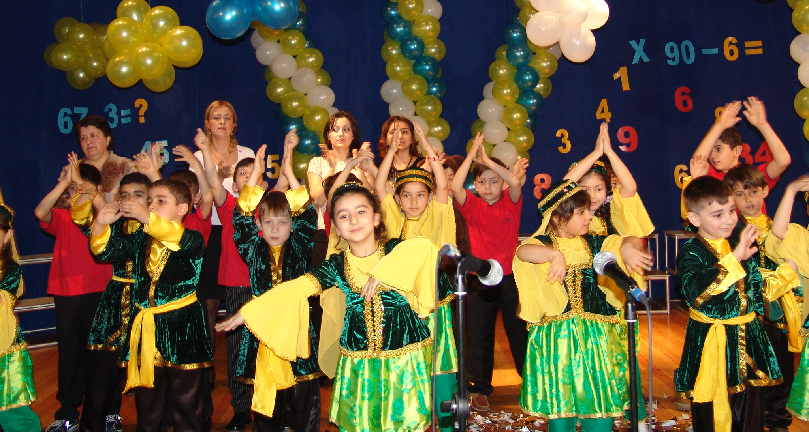
"Dunya" School was founded in September 1998 under the auspices of Khazar University. The School is accredited by the Ministry of Education of Azerbaijan.
Khazar University plays an important role in arranging the School curriculum and in employing qualified professionals. In short, Khazar University is responsible for the present and future life of the School.
"Dunya" School has excellent facilities including a rich and cozy library, a modern computer lab with access to the internet, bright and spacious classrooms, an art studio, a beautiful theatre with modern lighting and sound system, sport facilities and a dining room, and school buses for providing students with transportation to and from the School.
The students study 5 days a week. On Saturdays extra-curricular activities are arranged.
"Dunya" is a day school where students stay for full time education from 8:30 a.m. till 4 p.m.

Admission Criteria
The School accepts students from diverse backgrounds and with a large range of skills and academic abilities.
However, the School reserves the right to refuse admission to students whose enrollment may be detrimental to the School.

School’s Organization
The School is divided into 4 departments related to 4 stages of School Education: Preschool (3-5 years old), Primary (1st - 4th grades), Basic or Middle or Lower Secondary (5th - 9th grades), and Secondary or Upper Secondary (10th- 11th grades).
The School has an internal quality evaluation system controlled by Khazar University. The responsibility for developing in-service teacher training has also been left to Khazar University School of Education.
Instructors are selected for their knowledge, moral qualities, enthusiasm and care for children.
The Parent and Teacher Association organizes and supports events and programs and serves as an important link between parents and the School.

Education
The learning style at the School is cooperative, friendly and student-oriented. The basic element of the learning process is formed by the student's self evaluation - by discovering their own potential, taking on responsibilities, possessing self-confidence, and therefore using their creativity and imagination in every aspect of life.
The school has an "open" and supportive environment and students are free to express their needs and challenges.
At "Dunya" School the medium of instruction is Azerbaijani (Azeri) with English as a second language. Use of English as a second language of instruction serves the purpose of preparing children to find links between their community and the world. The students learn and use English in an interactive way, connecting their knowledge with real life situations, using demonstration techniques.
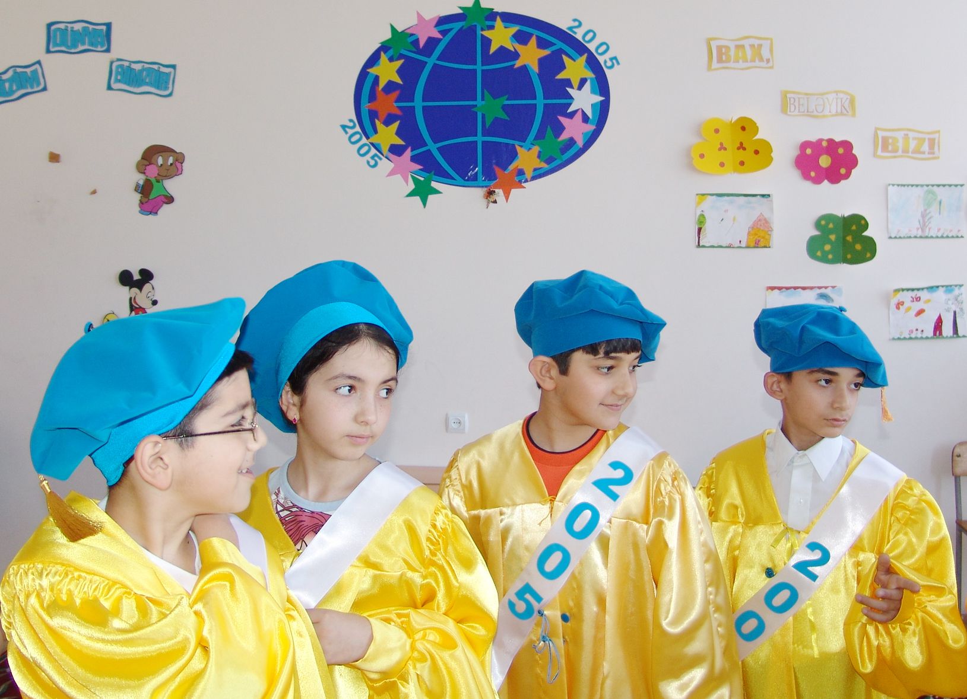
Art, music, drama, dance and chess round out the education program. Qualified professionals conduct classes in these fields that are equally important in developing a balanced character.
The classes are not limited to the classroom walls. Art exhibitions of "Dunya" students are often organized at the School as well as nationally, which stimulate their creative activity.
Extracurricular activities help children develop confidence in themselves and work with others. There are also trips to museums, historical places, national parks, art galleries, theatres, nature, colleges and, of course, Khazar University.

Preschool
"Dunya" Preschool Education Program is based on discovering and developing whatever capacity the children may have and provide them with every possible opportunity to pursue successful formal education.
The preschool classes provide a happy pleasing environment where children are motivated to learn. The instructors act as facilitators, helping children to discover and grow on their own.
The curriculum is attuned to cognitive, physical, social and emotional development of the individual child. In order to reach the goals of the education program the following activities are performed:
- Azerbaijani language practice
- Preparatory studies for reading and writing
- Simple math knowledge (numbers, basic geometrical figures)
- Nature and Life
- English through games
- Art
- Music
- Games
- Computers
- Sports
- Free time activity.
The program is improved by songs, dramas, poems, storytelling and it encourages children's creativity and imagination.
We make the system more active through work, play, travel, observation, etc. The thematic units for each week are designed with extreme care according to the interests, individual needs and capacity of children.

Primary School
Dunya Primary School offers its students the best academic environment, active student involvement, a balanced combination of established tradition and modern ideas and facilities. Beginning from the 3rd grade students are taught by teachers specialized in subjects, providing them with a greater exposure to the different approaches to the learning experience.
There are different classrooms purposefully designed for each subject.
There is no place for memorizing conceptual knowledge, neither is there any homework that doesn't serve a meaningful purpose.
The intention is to teach our students literacy, basic mathematics and to help them love their School through various activities.
Slow learners are given extra lessons.

Core Courses
- Azeri language (writing)
- Reading Skills
- English
- Third language
- Computer Skills
- Science
- Math
- Music
- Art
- Sport
- Dance

Middle and Secondary Schools
According to "Dunya" School's approach, high school education should prepare students for an independent life and the university entrance exam. Qualified teachers support their students to help them become good citizens with critical thinking ability, who will be able to cope with modern science and technology, humanities and social studies.

Core Courses
- Azerbaijani language
- Azerbaijani Literature
- World Literature
- English
- Third languages (for instance, Russian, Arabic, French, Spanish, German, Italian, Chinese, Japanese, etc)
- Math
- Science (physics, astronomy, biology, chemistry)
- Computing
- World History
- History of Azerbaijan
- Geography
- Music
- Art
- Sport
- Dances and/or Drama
- Ethics
Additionally "Dunya" Secondary School students may register for Elective Courses like political science, economics and business, sciences, aesthetics, sociology, anthropology, computer science, art, music, chess, etc.
Senior students have a unique opportunity to register for a few classes at Khazar University to earn credits for their future higher education.

Parental Relations and Involvement
It shouldn't be forgotten that the education begins at home and the parents are the teachers of their children. The active parental support is an essential element in the child's educational success.
School and the family should be in association so that the children can grow social, proper and happy individual.
At our school parents have an active and enthusiastic role in the academic and extra-curricular activities.
Parents are advised to review the school day with their children in order to draw the school experience into the home life.
Periodic parent-teacher meetings give parents an opportunity to chart their children's individual school records and discuss any questions related to their school life with teachers.

Faculty and Staff Members
Hamlet A. Isaxanli (DS in Mathematics)
MS 1970 (Azerbaijan State University, Baku)
PhD 1973 (Lomonosov Moscow State University, Russia)
DS 1983 (Steklov Institute of Mathematics, Moscow, Russia)
Research interests: Mathematics. Education. Literature. History of Science and Ideas. History of Culture and Education. Translation Studies.

Bahlul Abdullayev (DS in Philology)
MA 1967 (Azerbaijan State University, Baku)
PhD 1974 (Institute of Literature, Baku)
DS 1989 (Institute of Literature, Baku)
Research interests: Folklore of Azerbaijan. Education.

Afgan A. Abdullayev (DS in Philology)
MA 1978 (Azerbaijan State Institute of Foreign Languages, Baku)
PhD 1996 (Azerbaijan National Academy of Sciences, Baku)
DS 2001 (Baku State University, Azerbaijan)
Research interests: Cognitive Linguistics. Teaching English Texts. Interaction of Languages. Text Comprehension Models.

Ismat S. Ahmadov (PhD in Biophysics)
MS 1974 (Baku State University, Azerbaijan)
PhD 1979 (Tbilisi State University, Georgia)

Research interests: Education. Methods of assessment.

Isaxan A. Isaxanli (PhD in Education)
MS 1984 (Azerbaijan State University, Baku)
MA 1998 (Khazar University, Baku)
PhD 2003 (Azerbaijan State Pedagogical University, Baku)
Research interests: Education, Principles of Selection and Admission in Education. History of Education.
Eldar A. Shahgeldiyev (PhD in Philosophy)
MA 1978 (Azerbaijan Pedagogical University of Foreign Languages, Baku)
PhD 1991 (Institute of Philosophy and Law, Azerbaijan)
Research interests: Educational Sociology, Psychology and Policy. Moral Psychological Climate of Labor Units and its Role on Personality Development. TESL.

Fuat H. Rasulov (PhD in Production Management)
MS 1972 (Azerbaijan Institute of Oil and Chemistry, Baku)
PhD 1988 (Moscow Institute for Management of Public Economy, Russia)
Research interests: Business Management and Education.

Nigar M. Aslanova (PhD in Mathematics)
MS 1992 (Baku State University, Azerbaijan)
PhD 2003 (Institute of Mathematics, Baku, Azerbaijan)
Research interests: Teaching of Mathematics. Singular differential operators. Inverse problem of scattering theory for non self-adjoint operator.

Saadat R. Khudaverdieva (PhD in Biology)
MS 1986 (St. Petersburg State University, Russia)
PhD 2004 (Baku State University, Azerbaijan)
Research interests: Radiobiology. Influence of anthropogenic and natural radioactive pollution organisms. Teaching of Biology.

Leyla G. Muradkhanli (PhD in Information Systems)
MS 1988 (Azerbaijan Institute of Oil and Chemistry, Baku)
PhD 1992 (Azerbaijan State Oil Academy, Baku)
Research interests: Teaching methodologies in Higher Education. Information Technology. Decision Sciences. Design and Development of Artificial Intelligent Systems.

Agil X. Aliyev (PhD in Biology)
MD 1978 (Azerbaijan State Medical Institute, Baku)
PhD 1995 (Institute of Physiology, Baku)
Research interests: Animal and Human Physiology. The study of influence of opioid pepdits on emotional reactions. General mechanisms of pains and their influences on autonomic functions.

Tatyana N. Zaytseva (PhD in Economy)
MS 1973 (Azerbaijan State Institute of Economy, Baku)
PhD 1979 (Azerbaijan State Institute of Economy, Baku)
Research interests: Educational innovation, Bibliometrics, Library research; Education and training for library and information service workers and students.

Kifayat Agayeva (MS in English)
MA 1976 (Pedagogical Institute of Foreign Languages, Baku)
Research interests: Women’s rights, parent-children relationship, mutual relationship and problems of ethics, gender and globalization in the contemporary society.

Gultakin Binnatova (PhD in Philology)
MA 1994 (Baku State University, Azerbaijan)
PhD 2007 (Baku State University, Azerbaijan)
Research interests: Linguistics. Folklore of Azerbaijan. Methodology of teaching.
Vafa S. Bunyadova (PhD in Philology)
MA 1993 (Institute of Russian Language and Literature, Baku)
PhD 2005 (Baku Slavic University, Azerbaijan)
Research interests: Theory of literature. Bibliography. Linguistics. Journalism. Folklore of Azerbaijan.

Aydin Gambarov (PhD in Philology)
MA 1976 (Baku State University, Azerbaijan)
PhD 1987 (Baku State University, Azerbaijan)
Research interests: Linguistics. Methodology of Azerbaijani literature.

Ahmad Fathey Ahmad Shoeib (PhD in Education)
BS 1999 (Ain-Shams University, Egypt)
MA 2004 (Al-Azhar University, Egypt)
PhD 2007 (Al-Azhar University, Egypt)
Research interests: Theory of education. Principles of modern education. History of education.

Yegana Axundova (MA in Music)
MA 1983 (Azerbaijan State Conservatory, Baku)
Research interests: Theory of classic music. Culture of music. Teaching methodology of music.

Kamil Aliyev (MSW, MBA)
BS 1999 (Azerbaijan State Oil Academy, Baku)
MBA 2001 (Azerbaijan State Oil Academy, Baku)
MSW 2007 (Washington University in St. Louis, USA)
Research interests: Parent-Teen Communication. Impact on Adolescent Sexual Behavior. Predictors of Risky Sexual Behaviors among Adolescents in Foster Care System. Children with Disabilities.

Lala K. Ganiyeva (MA in Education)
BS 1992 (Baku State University, Azerbaijan)
MA 2001 (Michigan State University, USA)
Research interests: Methodology of learning. Theory of education. Principles of teaching.

Ilham Mustafayev - DS in Education
Shikar Huseynov – PhD, History of Education
Rovshan Abbasov – PhD, Geography
Babakishi Garacayev – PhD, Technology and Science Education
Farida Huseynova – Associate Professor, Design
Ulviyya Agayeva - PhD candidate, History Education
Aghalar Mammadov - PhD in Phylosophy
Gulchin Mehraliyeva - Associate Professor, Psychology
Nailaxanim Isayeva - MA, Instruction and Teaching; Director of “Dunya” School
Marufa Madatova - MA, Instruction and Teaching; Deputy Director of “Dunya” School
Lidiya Gamidova - MA, Instruction and Teaching
Nushaba Mammadova - MA, Political Science
Shahla Ismayilova – MA, Instruction and Teaching
Gunel Mammadova – MA, Instruction and Teaching
Shafag Abilova – MA, Instruction and Teaching
Gulnara Abbasova – MA, Instruction and Teaching
Aytac Azizova – MA, Bibliography
Madina Rzayeva – MA, Library Science
Samira Maqsudova – MA, Bibliography
Gulustan Mammadova – MA, Political Science, Education
Narmin Humbataliyeva – MA, Language Education
Ayten Zargarova – MA student, High School Teacher
Emil Rahimov – MA student, High School Teacher
Rafig Hashimov- MS, Communication
Masuma Haciyeva – MS, Science Education
Banovsha Bayramova – MS, Science Education
Seljan Rzayeva – MS, Computer Science
Xalida Malikova – MS, Computer Science
Mammadrza Askerov – MS, Mathematics Education
Nigar Askerova - MS, Mathematics Education
Eminaga Mammadov – MS, Mathematics Education
Dilara Hasanova - MS, Mathematics Education
Sevda Abbasova – Preschool Education
Lala Abdullayeva – Preschool Education
Kamilla Agayeva – Preschool Education
Nurana Mammadova – Elementary School Education
Vusala Shahmirova – Elementary School Education
Konul Ismayilova – Elementary School Education
Irada Nabiyeva – Elementary School Education
Gulshan Gurbanova – Elementary School Education
Mirvari Agayeva – Elementary School Education
Gunel Gasimova – Elementary School Education
Shahla Nabiyeva – Elementary School Education
Nigar Faxraddinova – Elementary School Education
Nurana Siraczade – Elementary School Education
Nurlana Cafarova – Elementary School Education
Bilgeis Zeynalova – Elementary School Education
Aybeniz Shahvaladova – Elementary School Education
Chichak Qarajayeva - High School Education; Deputy Director of “Dunya” School
Parvin Aliyeva – High School Education, Biology
Pustaxanim Safarova – High School Education, Biology
Nigar Safarova – High School Education, Russian Language
Natavan Tagizade – High School Education, History
Zulfiyya Sadixova – Music Education
Aida Hamzaliyeva – Music Education
Rana Rustamova – Sports Education
Sevda Cafarova – English Education, Conversation Club supervisor
Sabina Minasazova – Music and Dance Education
Alibanda Aliyev – Music and Dance Education
Lyudmila Sotova – LIC, Electronic and Information Services, Head of department
Elnara Bayramova – LIC, Circulation Desk
Camila Aliyeva – LIC, Circulation Desk, Head of department, Economics and Management library
Tahira Mammadova – librarian
Sona Mammadova – librarian
Sabina Alimardanova – librarian
Aytel Karimova – librarian
Samira Huseynova – librarian
Sakina Babayeva – librarian
Rahim Balakishiyev – LIC, system administrator

