Azərbaycan Arxeologiyası 2001
23
Azerbaijan Archeology Vol.: 3 Num.: 1-4

6.
MORTUARY CONSTRUCTIONS OF THE CULTURE OF SUBTUMULUS CRYPTS
Tufan Akhundov (Azerbaijan NAS the Institute of Archaeology and Ethnography)
The birth and the development of notion of the universe maked a man take care of his deceased and accomplish mortuary rites. The other world was perceived as
natural development of real life and in
X. ,-, :-:^V;•'/..:.-,. analogy it needed its attributes. It im-
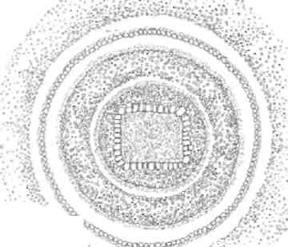
pelled to construct "houses for the dead" representing mortuary structures which reflected the elements of really existing. The interpretation of remains of ancient interments gives in a certain degree the opportunity to restore the mortuary rites and constructive-planning reconstructions of these monuments. It also helps us to restore the shapes and organization of real ancient dwellings.
So by the use of all these means it becomes possible to study world outlook of the population that had left these monuments.
•%
'••^'.'-••;';-:"v^.' -■':'• ■.-■'■'
In cultures with settled way of
life, stationary settlements and lasting
dwellings, sepulchral structures settled
Fiql
down near the necropolises are simplified.
At the same time actively cattle-breading cultures with frequent territorial
transference, temporary settlements and dwellings considerably moved off from
necropolises gave great consideration to organization of sepulchral structures.
They built up real dwellings for the invitation of the dead kinsmen and accomplished magnificent rites.
In the 2nd half of the 3rd millennium B.C. a number of cultures of traveling cattle-breeders began establishing in the territory of the South Caucasus instead of the settled Kura-Arax cultural tradition. One of these cultures was the culture of the sub tumulus crypts that was widened at the territory of Low and High Caucasus in the middle stream of Kura mainly at the territory of the Azerbaijan Republic (Fig. 1). Nowadays, only sepulchral monuments with characteristic constructive-planning remained from this culture. These burial places let us reconstruct real tribal dwellings of the bearers of this culture:
The majority of the discovered monuments are graves in sepulchral chambers, covered by embankment from burial mounds. The embankments are mainly made from cobble-stone, sometimes with inclusion of gravel and earth. On some objects was also observed a certain order in the choice and stowage of materials. For example, the

Azərbaycan Arxeologiyası 24 Azerbaijan Archeology
2001 Vol.: 3 Num.: 1-4
center of the top was made from big stones but the parameter consisted of smaller stones and gravel. Sometimes one or more begirding rings of different width, material (boulders, cobble-stones, gravel, earth) and shape of laying-out are found in the burial mound's embankment along the horizon (Fig. I). They have 10-12 meters in diameter, 1,5 meters in height but it's possible to meet embankments of larger diminutions.
In spite of the ideological unity between the sepulchral chambers of the monuments they differ in plan, constructive peculiarities and place of organization. And all these factors, probably, is the reflection of the ways of ethno-cultural foundation and peculiarities of this culture and its place in the ecological space.
The sepulchral chambers of this culture are rectangular and round in the plan. They are built up at the horizon in the form of ground constructions or established in a hole as mud-huts. At the horizon and in holes the chambers are round-planned or rectangular. They have 6-30 meters in square (Fig. II, III).
The revealed remainders of the ground chambers are in its majority in the form of sub tumulus roundest squares reaching 4,5 meters in diameter and outlined by ditches (on the average 20 sm. in width, 50 sm in depth). In same cases there was fixed a passage-way in the eastern sector as, for example in the burial mound N°119 near the town Khankendi where the ditch outlining the ground in its North-eastern side wasn't locked. The ditch ends completing by plane parallel sections were forming the passage-way in the shape of a corridor that was partitioned off outside by stone slab (1,45x1x03m), established vertically 3. (Fig. II, 2).
The remains of scorched boughs, clay, various stock, blocked up bones of the dead were found in many ditches of the monuments, i.e, originally they had the elements of wooden constructions and they weren't filled up with earth closely. Probably ,these sepulchral chambers were made as a ground building in the form of hut with entrance in the eastern sector . It was built from of light wood and cane constructions which were dug in their foundation into the marked ditches and closed up in the shape of a cupola on the top. Their height, if to judge by the slab covering the entrance in burial mound N2İ19, was no less 1,5 meters.
Among the monuments there can be marked out a round ground in the complex of burial ground N°20 in which there was outlined a ground 6 meters in diameter. It isn't locked from the South-eastern side and makes on embankment. The remains of twenty two (22) pickets rotted below and searched on top remained in the ditch with the interval 0,9 met. from each other, i.e. protecting constructions fastened in ditches in other chambers which are marked out consisted of light building material turning into overlapping dome. In the present instance the greater diameter supposed more difficult and complicated construction of the overlapping. Probably that is what caused the reinforcement of light turluk-cane constructions by powerful poles-supports (Fig. Ill, 5).
There are two objects between ground chambers in which the sepulchral ground is outlined not by a ditch but masonry of 40-45 sm. in depth without marked-out entrance . The structure of filling traced on one of them originally supposes the availability of light wooden constructions above the chamber. All these facts allow suppose that the masonry is only the foundation of the walls of the chamber but the
Azərbaycan Arxeologiyası 25 Azerbaijan Archeology
2001 Vol.: 3 Num.: 1-4
upper side and overlapping are made from light wooden turluk-cane constructions. Probably, the entrance also was above the masonry (Fig. Ill, 3, 4).
The constructive variety also marks out sepulchral chambers arranged in holes where the same modes as in the ground chambers were used but with regard for new conditions. Their depth was on the average 1,5 meters, many of them were analogous to ground buildings and had the entrance in the eastern sector (Fig. II, 1, 3, 5). These entrances also differ: in one case it is made in the shape of a chamber but with lesser depth and its external angles are marked by flanking stone slabs; in other cases there isn't any additional cutting, but we found one or two slabs established vertically near the edge of the sepulchral chamber as if they are marching the entrance disposing in the very overlapping of the hole (Fig. II, 4; III, 1, 2).
In some chambers the bottom among the foundation of walls is outlined grounds at the horizon the foundation of light turluk-cane barriers with only difference that they didn't form the volume of the construction but revolted (strengthened) the subsoil walls of holes.
In the light of all that have been said two monuments settled near other are more note-worthy. The burial mound -N2119 with the ground chamber (Fig. II, 1) has a ditch outlining the sepulchral ground which is dug at the horizon and was intended for the strengthening of the foundation of ground building.
The burial mound N2İ03 has the analogous chamber in a hole (Fig. II, 1) that is at the bottom of the hole among the walls and was intended for strengthening the foundation revolting the wall of the construction in the form of a dome. In that case the goods of chambers are identical in both cases independently of the place of settlement. They both are round -planned with 4,5 meters in diameter and have right-angled entrance in the eastern sector.
There were used stable building materials in some rectangular hole chambers. The walls of two chambers in the settlement of Osman bozu (Ne4 and N°5) are revolted by blocks established vertically.
Their foundation in one of the chambers is strengthened in the ditch outlining the hole. In another one its strengthened by frame made from 4 logs, one for each wall. The entrance in one of these chambers was in the form additional ringle-angled cutting, in the other it was in overlapping as flanking stone was rising near the edge ofthehole (Fig. II, 3; III, 1).
These chambers were overlapping by tampered layer. The ends of the timbered layer in one of the burial mound of Osman bozu (N2I) is put on the logs laying by one among the chamber from each side. The second couple of logs was put above the ends of the timbered layer (Fig. Ill, 1).
Like the chambers on the horizon the hole chambers also were made from stone. The walls of the chamber in burial mound N°7 near Borsunlu village are laid out by little plane slabs that were put flatways on clay mortar. The overlapping is a timbered layer (Fig. II, 6).
The floors of ground and hole monuments are made even, rammed and flagged by plane stone.

Azərbaycan Arxeologiyası 2001
26
Azerbaijan Archeology Vol.: 3 Num.: 1-4

Fig II.

f
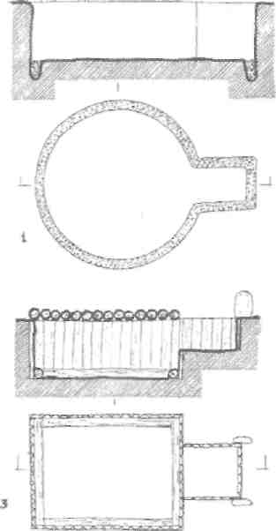
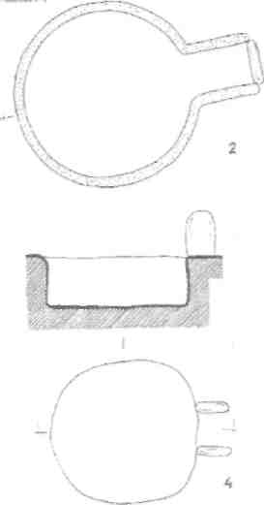

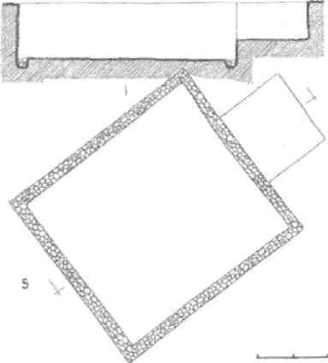
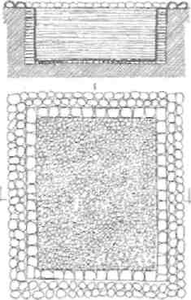
Azərbaycan Arxeologiyasi 2001

27
Azerbaijan Archeology Vol.: 3 Num.: 1-4

Fig. Ill

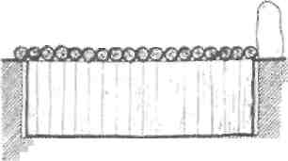
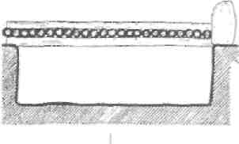
/ f ',:',,%,

 | A* v.'vyv | WW ". |  |  | ---
 |  | asac2as2= | > «. * | ¹ » a.« | OSS
CZD

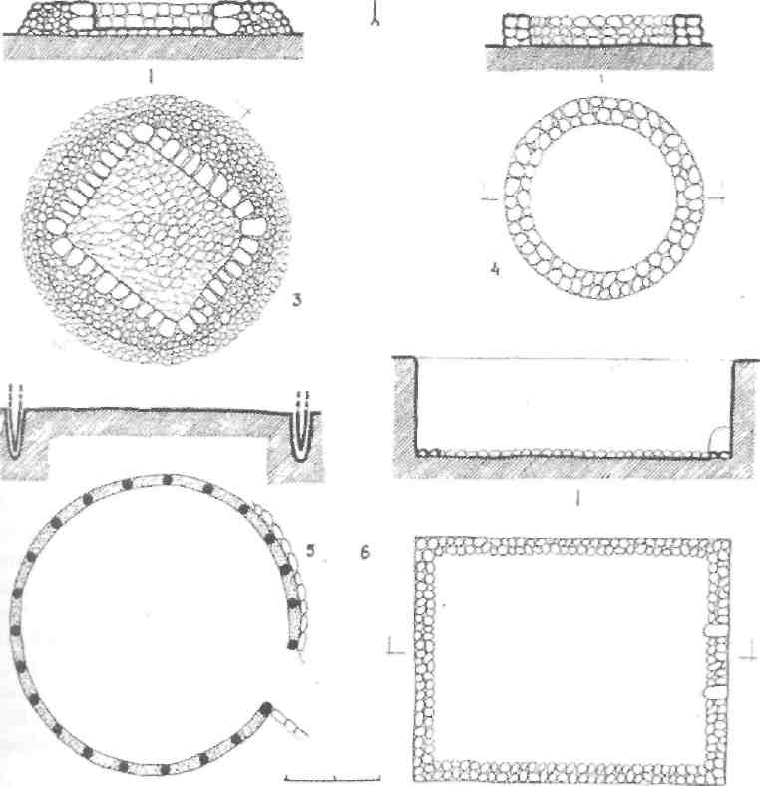
Azərbaycan Arxeologiyası 2001

28
Azerbaijan Archeology Vol.: 3 Num.: 1-4

The characteristic feature of the sepulchral monuments is a large number of the deceased in one grave and sometimes there are even some tens of them. One by one or by group or whole grave were immediately immured by stratum of clay and stone or underwent a certain fiery rite. This rite in various forms presents just about in every chamber, mainly in its western side that is opposite to the entrance. That's why the deceased in the western part of the chambers in some monuments were scorched or burnt to ashier but the deceased's in its eastern part are either burnt round or not but without traces of flame.

The characters of the position of a corpse, the ways of immuring and treatment by flame exclude simultaneous interring of all deceased's of one grave. On the basis of all these we can conclude that they were sepulchral constructions for the lasting functioning as a crypt where the other dead members of a kin were also buried time by time.
Probably, with a view of inflectional security the deceased's or their groups were bricked up or subjected to flame. The presence of fiery traces mainly in the western part of a grave reflected the ancient notion about the process of transition to the other world that was considered to be opposite to the eastern disposition of really existing entrance (exit) into the grave. The presence of two and even three layers of the immured deceased's also confirms the lasting use of the crypts.
Thus, from all that have been said we can make a conclusion that the real dwelling of bearers of the culture of sub tumulus crypts are either ground ones or in the shape of mud-huts. Graves on the horizon were in the form of ground constructions from light turluk-care constructions turning into the overlapping in the form of a cupola. The ground constructions are mainly round-planned. In certain cases the light constructions leant on masonry or were put round by it.
The dwellings in the form of mud-huts were arranged in a rest angular holes, their walls were strengthened by turluk-cane facing, blocks, masonry. The overlapping was made from logs in its greater part, but probably, there were also existed light constructions, too.
In both versions the floors were rammed, rarely flagged. The entrance was orientated to sunrise and the hearth was arranged near the distant eastern wall.
BIBLIOGRAPHY
-  ..,     (  ), , 1999 .
-  ..,   -    1938 .,    , 1939 ., № 4, . 81-83;  ..,       .     , 1944 ., № 2, . 91-94; ..,   -  .      , . XX, 1948 ., . 21-24; Nərimanov İ.H., Gən-cəçay rayonunun arxeoloji abidələri, Baki, 1958; Kəsəmənli H.P., Cəfərov H.F., Şəmkir arxeoloji əkspedisiyasi tədqiqatlarının hesabatı (1977 il), Azərbaycan, MEA Arxeologiya və Etnoqrafiya institutunun Çöl-Tədqiqatları şöbəsinin arxivi, № 216, s. 3-8;Kəsəmənli H.P., Cəfərov H.F. Əliyev T.R., 1978-ci ildə Şəmkir ekspedisiyəsı tədqiqatlarımn

Azərbaycan Arxeologiyası 29 Azerbaijan Archeology
2001 Vol.: 3 Num.: 1-4
hesabatı, Azerbaycan MEA Arxeoloqiya və Etnoqrafiyə institutunun Çöl-Tədqiqatları şöbəsinin arxivi, № 239, s. 5-13; Cəfərov H.F., Borsunluda ilk tunc dövrü kurqanı, Azerb. SSR EA Xəbərləri, 1985 , № 3, s. 79-88;Cəfərov H.F., Qarabaqda yeni ilk tunc dövrü abidəsi, Azerb. SSR EA Xəbərləri, 1987 il, № 3,s. 100-108; Axundov .1.,   ,   , .1, , 1993 ., . 121-135.
-  ..,  ..., . 13-18.
-  ..,  ..., . 21-24.
-  ..,  ..., . 13-18.
-  ..,   -...
- Kəsəmənli H.P., Cəfərov H.F., Əliyev T.R., 1978-çi ildə Səmkir arxeoloji...
- Kəsəmənli H.P., Cəfərov H.F., Səmkir arxeoloji...
- Cəfərov H.F., Borsunluda ilk tunc...

  «  ».
 
        III    .            .     ,      .   - ,        ,     ,        .

