JAPAN – AZERBAIJAN BILATERAL RELATIONS

Tadahiro ABE
(Ambassador of Japan to Azerbaijan)

I. General Observation

International Situation

(1) In the last decade of the 20th century, the world was shaken by major upheavals such as the end of the Cold War regime, acceleration of economic globalization, and revolutionary advances in information technology. With the international community facing new waves of change in the 21st century, interdependence between countries can only continue to increase. To address the many growing problems that transcend national boundaries – security issues, terrorism, economic issues, environmental degradation, illegal drugs, refugees, etc. – the extensive cooperation of all countries involved is becoming increasingly critical. While effectively addressing those problems deriving from the changes taking place, Japan's foreign policy in the new century seeks to actively promote the security and prosperity of the entire international community, in the recognition that this is inseparable from the security and prosperity of Japan itself.
(2) Since its admission to the United Nations in 1956, Japan has regarded its commitment to the United Nations as one of the main pillars of its foreign policy, and has been contributing to the UN budget for 19.5%, next to the US which has the largest shares of 22 % of the total budget. Japan has been working for the international peace and security. It works for resolution of regional disputes through personnel and financial support provided to United Nations peacekeeping operations and other international efforts. It is actively supporting international endeavors for conflict prevention and active promotion of arms control and non-proliferation, and fight against terrorism and to solve problems in areas such as environmental degradation, illegal drugs, and population growth as well.
(3) The significance of economic issues as a component of international relations has also been increased in recent years, making a global economic stability a critical issue in Japanese diplomacy. Recognizing the responsibilities of a country as a world's second largest economy, Japan has been making sincere efforts to promote healthy economic development worldwide through bilateral relations as well as its relation with international organizations such as the IMF, the WTO, and the OECD. Japan has also been providing financial and technical assistance to developing countries via official development assistance (ODA) program in order to contribute to their economic development as well as improvement of people's welfare. Japan was the world's largest aid donor all through 1990s, and now the second largest global donor in 2005 just next to the US.

Main target of Japanese diplomacy

(1) Japan is a peace-oriented country, as its Constitution clearly stipulates as follows, and it is reflected upon its pursuance of the foreign diplomacy:

Article 9 of the Japanese Constitution: Aspiring sincerely to an international peace based on justice and order, the Japanese people forever renounce war as a sovereign right of the nation and the threat or use of force as a means of setting international disputes.

(2) In the international environment marked by economic globalization and ever- increasing interdependence among the member countries of the international community, Japan's economic growth and security are intertwined to, and dependent on, the peace and stability of both Asia-Pacific region and the rest of the world. In order to ensure its security as well as regional peace and stability, Japan is engaging in an active diplomacy at various levels of international affairs. These efforts include: (i) attempts to resolve individual conflicts and confrontations, bilateral and multilateral dialogues and cooperation to promote regional stability; (ii) political and security-related dialogues and cooperation, aimed at increasing the policy transparency of Asia-Pacific countries and building trust between them; and (iii) the achievement of greater social stability in various regions through a support for and cooperation in the regional and individual economic development.

II. Contemporary Japanese Economy

The Japanese economy is the world's second largest economy since 1968 next to the United States. Japan's real gross domestic product (GDP) was $4.7 trillion in 2004, and its per capita GDP ranked third in the global economy in 2003. Although, more than three decades characterized primarily by solid economic growth, Japan's economy entered into recessional process in the 1990s. The extended stagnation of the economy made it necessary for Japan to reform its economic structure fabricated through its 50 years of postwar economic experience. The standardized mass production practices refined by Japanese industry have enabled Japan to produce automobiles, electronics, and many other products that are highly competitive internationally. However, as the world's economic focus shifts to software, information, and diversification, Japan needs to respond to changing economic trends. In order to promote economic recovery and facilitate growth in the 21st Century, the government is reforming its economic structure through administrative operations, deregulating the economy, and liberalizing the financial system.

High- Growth Era

At the end of the Allied Occupation in 1952, Japan ranked as a less-developed country, with per capita consumption a mere one-fifth that of the United States. During the period 1953-1973, the economy grew with unprecedented rapidity (the average growth rate was 8.0% per annum overall and 10.6% during the 1950s). Real output per person in 1970 was 2.5 times higher than in 1960, and, Japan became the world's second largest economy in 1968. This rapid growth resulted in significant changes to Japan's industrial structure. Production system shifted from a reliance on agriculture and light manufacturing to a focus on heavy industry, machineries and, gradually, service sector. Urbanization also progressed rapidly.
The first major economic expansion, the Iwato Boom (1959-1961, average growth 12.2%), touched off an investment occurred in 1963-1964 (average growth 11%), 1966-1970 (the Izanagi Boom, average growth 11.6%), and 19721973 (the Tanaka expansion, average growth 8.9%)
Many factors contributed to rapid growth, including the shift in employment from a low-productivity primary sector to a high-productivity manufacturing sector, combined with a high technical knowledge and a skilled and educated labor force with a strong commitment to work. In addition, macroeconomic policies were conducive to growth, the international environment was blessed with stable commodity prices and expanding trade, and investment was high in magnitude. Together with introduction of a better and innovative technology, productivity of the industry increased rapidly.
Japan became a member of the International Monetary Fund (IMF) in 1952 and the General Agreement on Tariffs and Trade (GATT) in 1955. Around 1960, Japan committed itself to trade liberalization by seeking IMF article 8 status and deciding to join the OECD, both of which were realized in 1964. Tariffs and quantitative controls on most tradable goods were removed by 1970, and, with the exception of agriculture and some high technology products, most non-tariff barriers were eliminated by the 1980s.
Indirect government assistance came in the form of tax breaks, treasury investment and loans, and the policy of administrative guidance of the Ministry concerned. Most industries obtained some government favors, and it is unclear that any industry was effectively promoted relative to its rival industries. However, domestic policies did result in a minimal presence by foreign firms in most sectors.
From the 1950s, the banking system was gradually rebuilt. The stock exchange was reopened in 1949, but it did not develop into a major source of new funds until the 1980s. Corporate finance depended on bank financing as the major sources of outside funds, giving rise to a capital structure dominated by debt. To prevent takeovers, enterprise groups, or keiretsu, actively sought cross-shareholdings with a variety of firms, including major financial institutions. Small and medium-sized enterprises remained relatively important during this period, employing nearly three-quarters of the labor force.
During the 1950s the major exporters and thus the leading firms were in textiles and other light industries, whose products were marketed by general trading companies; government promotion. However, focus was gradually shifted to a heavy manufacturing industry located in major coastal industrial complexes: During the 1960s, the iron and steel industry and the shipbuilding industry came to the fore, followed by the chemical industry and in the early 1970s the electronics industry; the automotive industry rose to prominence in the late 1970s. Exports were important, especially for textiles and shipbuilding, which were aided by a rapid increase in world trade throughout the 1960s.
Rapid growth was not without its problems. Until the late 1960s, Japan faced chronic balance-of-payments difficulties. Inflation also proved to be problematic, at least comparatively. The spread of pollution and pollution-related diseases went unchecked until the late 1960s.

Matured Economy

(a) By 1973, many of the factors that supported rapid growth lost their strength. First, Japanese industry had caught up with the best practices abroad; improving productivity required more resources than in the past. This in turn reduced the profitability of new investment, which fell to a lower level after 1974. The international environment also became less favorable, due mainly to the revaluation of the yen and trade frictions with the United States. The Japan United States textile talks of 1969, a worldwide commodity price boom that culminated in the quadrupling of oil prices during the oil crisis of 1973, and the movement of the yen to a floating rate in 1973, all these factors worked to slow Japanese economic growth.
Even before the October 1973 oil crisis, the government had started to slow the economy in response to rising inflation. Combined with the impact of a quadrupling of oil prices, gross national product (GDP) fell 1.4 percent in 1974, the first actual decline since the 1950s. Growth slowed from the 10 percent level to an average of 3.6 percent during 1974-1979.

(b) After the 1985 Plaza Accord, the yen rose sharply in value, reaching y120 to a US dollar in 1988, twice its average 1984 value and three times its 1971 value. As a result, after 1986 the trade surplus gradually shrank.
Nevertheless, this time around, domestic demand increased to pick up the slack. Monetary policy was eased four times during 1986, as the Bank of Japan lowered the discount rate from 5.0 percent to 2.5 percent, the lowest level since World War II. Consumption began increasing in 1986, and investment took over during 1978-1990; in fact, corporate investment rose to 19.6 percent of GNP in 1988 and 21.7 percent in 1989, exceeding total investment in plant and equipment in 1989 for the entire United States in both percentage and value.
With higher stock prices, new equity issues skyrocketed, becoming a significant source of finance for corporations for the first time since the crash of the Tokyo market in 1961. Banks found a new outlet for funds in real estate development. In turn, corporations attempted to maximize the productivity of their assets using real estate holdings as collateral for sock market speculations. The ensuing speculative binge (1986-1989) resulted in the so-called "bubble economy" in which land prices doubled and the Tokyo Nikkei stock market index rose 2.7 times.
Japan tightened monetary policy beginning in May 1989, and higher interest rates touched off a collapse of stock prices.

(c) According to the Economic Planning Agency (now part of the Cabinet Office), the Heisei Recession began in April 1991 and bottomed out in October 1993. The recovery since then, however, has been extremely slow. Subsequent upward momentum was undermined by negative factors such as the Asian economic crisis in 1996 and the bankruptcy of several large financial institutions, and the Japanese economy turned downward again in 1997, suffering a negative growth rate of -1.1 percent in 1998. Aided by emergency government spending measures, increasing IT-product demand, and external demand growth caused by the economic recovery in the World economy, Japan in 1999 showed signs of recovery and started a positive economic growth period. However, those upturns were heavily depend upon stepped-up external stimulus, and fizzled out when those effects wore off.

(d) Another economic recovery began in 2002 and has proceeded uninterruptedly since then. In February 2006, the upturn entered its fifth year, and if it continues to the year's end, it will become the longest phase of expansion since WW II. This upturn that began in 2002 is different from the previous one. It has been propelled by the private sector such as investment and private consumption.

III. Recent developments in the Azerbaijan-Japan bilateral relations

After a transformation of a global security framework in 1989, CIS countries became independent of the former Soviet Union. Japan recognized the independence of Azerbaijan soon after its declaration in 1991, and established diplomatic relation between the two countries. Since Japan is a peace-oriented country and targeting the materialization of global peace as an important part of its foreign policy. Development of Azerbaijan is very important from this point of view. Because it makes Azerbaijan possible to materialize peace and prosperity domestically, and to contribute to the regional peace and stability in the South Caucasian Region which constitutes an important part for realization of the global peace. That is why the Embassy of Japan in Azerbaijan has been making its best efforts, since its establishment, to promote mutual understanding between our two countries and to provide Official Development Assistance in various aspects of Azerbaijan's efforts toward social and economical reforms. The Government and the people of Japan are hoping to construct a real friendship between our two nations. As for the year of 2005 and thereafter, in particular, we have succeeded in materializing numbers of achievements between us from the viewpoint of promoting our meaningful relations as follows:

Conclusion of the discussion between Azerbaijan and Japan on "Succession of the Treaties inherited from the previous regime of the USSR"

Since we established our diplomatic relations in the year 1992, the Government of Japan and the Government of Azerbaijan have been discussing "Succession of the Treaties, which were concluded in the previous regime of the USSR" in order to realign legal foundation for our new bilateral relations. As the result of revitalizing our efforts from the end of 2004 and thereafter, we have finally succeeded in reaching agreement on this important issue after 13 years of interval between Embassy of Japan and the Ministry of Foreign Affairs of the Republic of Azerbaijan in May 2005. We believe that we can construct a more meaningful relationship between us as the result of resolution of this issue.

The further facilitation of the economic cooperation, including large-scale assistance to the improvement of economic infrastructure

With regard to the Official Development Assistance (ODA) of the Government of Japan to Azerbaijan, we have been rendering our assistance mainly through grant assistance, small-scaled Grass Roots grant assistance to Azerbaijan until recently. However, we found that there are diversified needs for this Development Assistance in Azerbaijan. With a view to facilitating better conditions for economic development and improvement of the people's welfare in Azerbaijan, the Embassy of Japan in Baku discussed with various Ministries concerned and decided to extend a large-scale financial assistance to Azerbaijan in the field of improvement of economic infrastructure, in addition to the traditional small-scale grant assistance programs, namely, "Shimal Gas Cycle Power Plant" Project : the total cost of the project is $ 274 million US Dollars. We had a signing ceremony on the Exchange of Note in this regard between Ambassador of Japan, Tadahiro ABE and Deputy Prime Minister, Abid SHARIFOV in May last year. We are hoping that this project will become of some help to increase the supply of electricity to the people of Azerbaijan and contribute to the development of economic activities of this country as well. As a result of all the efforts being done in the year 2005 and thereafter, the total amount of Official Development Assistance of Japan to Azerbaijan, covering a large-scale economic infrastructure project and various grass-root Grant Assistance, reached the highest amount ever materialized in Azerbaijan for the amount of more than $ 280 million US dollars during the past one and a half year.
After the calendar turns into year 2006, continuous efforts have been made by the Embassy of Japan to extend further assistance to various projects in Azerbaijan including such projects as school constructions and IDP assistances.

Opening of BTC Pipeline

We are pleased to see that ACG Oil Extraction Program proceeded smoothly and the opening ceremony of BTC pipeline was held successfully last year in Sangachal terminal. It is expected that the eventual shipping of oil from Jeyhan port will be materialized sometime in the former half of this year, which we expect to contribute to improvement of supply and demand situation in the Global Oil Market. As it is well known, Japan became a stakeholder of these projects by participation of the Japanese Companies such as "INPEX" and "ITOCHU" Oil Company.

Opening of the Embassy of Azerbaijan in Japan

As mentioned above it is vitally important for both Japan and Azerbaijan to have closer relations in order to develop and maintain friendly relations between our countries and work together for maintenance to the maintenance of the global peace and stability. From this perspective, it was expected to have Embassies both in Baku and in Tokyo. We were pleased that the Government of Azerbaijan finally decided to appoint a new Ambassador to Japan and to establish the Embassy of Azerbaijan in Japan in October last year. Since, we have Embassy of Japan in Baku and Embassy of Azerbaijan in Tokyo, we can start our diplomatic relations through Embassy in order to deal with our official communications in a more efficient way. This certainly is beneficial for both of us to have constructive relation between us.

Exchange Programs of the eminent people, facilitating mutual understanding between our two countries

(1) It is vitally important to promote mutual understanding through exchange of the peoples of our countries through various channels such as acceptance of trainees, dispatch of experts and acceptance of students. In the year of 2005, we have also increased this opportunities by sending eminent governmental officials and parliamentarians. We had a visit of Vice Foreign Minister Mr. Aizawa and Chairman of the Foreign Relations committee Mr. Harada of the Parliament of Japan respectively in 2005, and for the Azerbaijan side, you dispatched Deputy Prime Minister Mr. Sharifov to Japan also in 2005. We have succeeded in utilizing various channels to promote mutual exchange of the people for the purpose of facilitating mutual understanding between us.

(2) The most important program of welcoming H.E. President Ilham Aliyev and Mme. Mehriban Aliyeva to Japan was carried out under the initiative of Ambassador ABE from March 7 to March 10, 2006, in Tokyo. Representing a good relationship between Japan and Azerbaijan, the visit of Mr. President and Mme. Aliyeva became a meaningful opportunity to further promote our friendship to a more meaningful stage of our mutual relationship;
H.E. President Ilham Aliyev and Mme. Mehriban Aliyeva were received by His Majesty Emperor and Empress of Japan. Besides, Mr. President has had meeting with Prime Minister Junichiro Koizumi, and Foreign Minister Taro Aso respectively. In addition, Mr. President made Policy Statement at the Investment Seminar and at the Research Institute's Seminar.
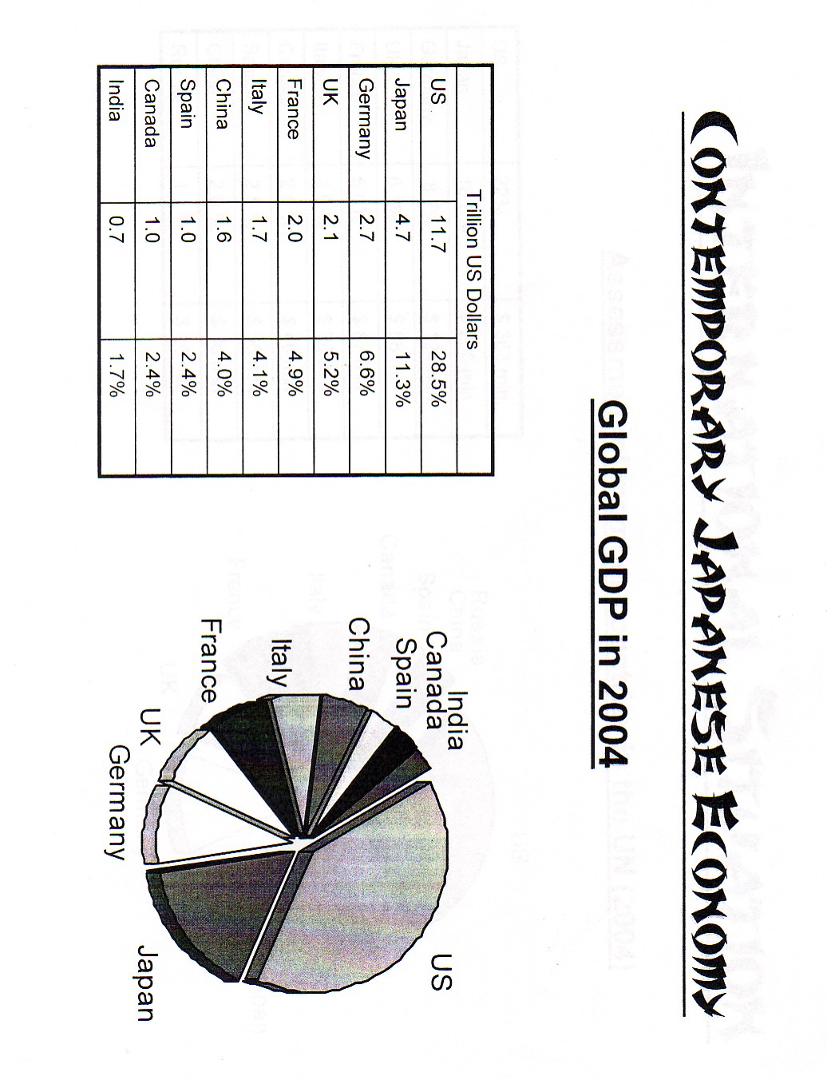
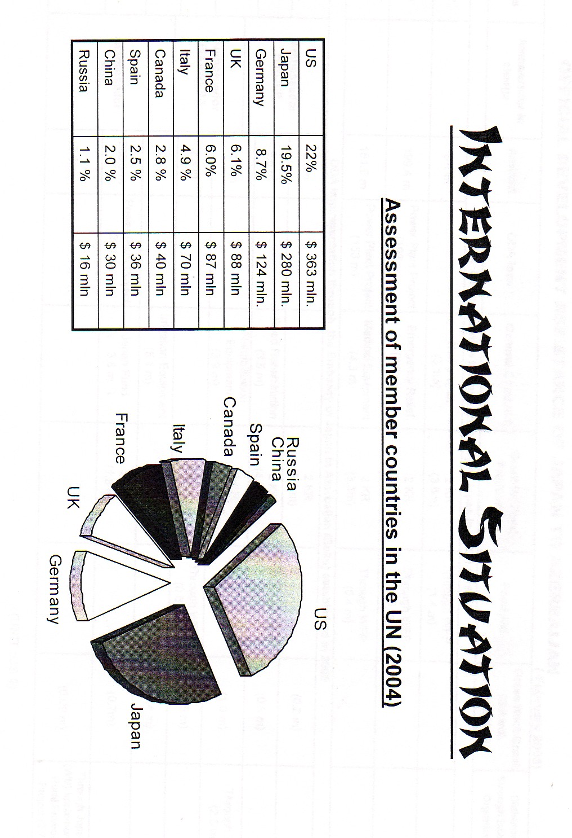

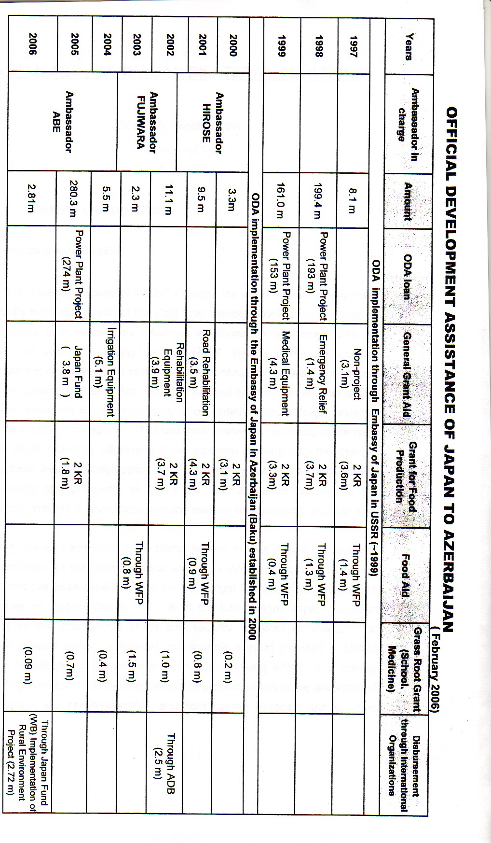

X ü l a s ə

YAPONİYA-AZƏRBAYCAN İKİTƏRƏFLİ MÜNASİBƏTLƏRİ

Tadahiro ABE
(Yaponiyanın Azərbaycandakı səfiri)

Məqalə üç hissədən ibarətdir. Birinci hissədə müəllif beynəlxalq mühit fonundaYaponiyanın ümumi iqtisadi və siyasi məqsəd və hədəflərini izah edir. İkinci hissədə tarixi perspektivdə Yapon iqtisadiyyatının inkişaf mərhələlərindın bəhs olunur və onların hər biri ayrı-ayrılıqda izah edilir. Üçüncü hissə isə Azərbaycan müstəqillik əldə etdikdən sonrakı dövrdə Azərbaycan-Yaponiya əlaqələrinin inkişafı mərhələlərinə həsr olunmuşdur. Müəllifin fikrincə hal-hazırda Yaponiya-Azərbaycan əməkdaşlığı bir çox sahələrdə, xüsusilə də, elm, mədəniyyət, texnologiya və iqtisadi inkişaf sahələrində böyük vüsət almışdır. Heç təəccüblü deyil ki, bu əməkdaşlıq nəticəsində Yaponiya Azərbaycanın inkişafı lahiyələrində başlıca donorlardan birinə çevrilmişdir.

