INFORMATION PROCESSING AND TEXTS
(REVIEW OF THE LITERATURE)

Afqan ABDULLAYEV
(Khazar University, Azerbaijan)

This review of literature will examine three bodies of literature related to information processing. First, reading comprehension will be defined, followed by a description of historical approaches to the study of comprehension and a detailed explanation of currently held theories and models of comprehension. Second, a model of short-term memory will be presented followed by an explanation of the role of short-term memory in processing text. Third, differences between good and poor readers will be described, followed by an analysis of possible sources of differences, including the differences that might be attributed to short-term memory.

Theories of Reading Comprehension

At the most basic level, reading comprehension is commonly thought of as extraction of meaning from text. A reader comprehends the meaning of a word, a sentence, or a passage of text when he or she apprehends the intention of the writer and succeeds in relating the writer’s message to the larger context of his or her own system of knowledge. Learning from reading requires that the reader select and extract relevant information, assimilate what is extracted to prior knowledge and to cognitive structures, remember for a time, at least, the meaning of what has been read, make inferences from the explicitly presented concepts – when and if required for understanding – and use appropriately what has been learned from the text (Gibson and Levin, 1975). Thus, reading comprehension involves correct association of meaning with word symbols, evaluation of suggested meanings in the context of the text segment being read, selection of the correct meaning from among the possible meanings in the text, the organization of ideas and concepts as they are read, the retention of the ideas and concepts, and the use of ideas or concepts in present or future activities (Dechant and Smith, 1977).
Early research in reading comprehension (Richards, 1929) concentrated on the features of the text and the writer’s intentions as essential factors in comprehension. To comprehend text, it was necessary to recognize and understand the literal meaning of the words on a page. It was also essential to go beyond the literal meaning and to recognize and understand the writer’s attitude towards his or her subject matter, the writer’s intentions or purpose for producing the text, and even the writer’s attitudes and assumptions about the readers.

Statistical Models
In the 1950’s and 1960’s, there was a shift away from writer-related factors to an emphasis on the components of reading comprehension. The statistical technique factor analysis made it possible to isolate some of the components thought to underlie comprehension and to identify the percentage of unique variance that each component contributed. Statistically determined models of comprehension (Holmes, 1965; Holmes and Singer, 1964; Singer, 1969) described the combinations of factors needed for power and speed in reading. Four factors – word recognition, word meaning, analysis of morphemes and reasoning in context – were found to account for 90 percent of the variance in reading skill or power. Three factors – reasoning in context, auditory vocabulary-word meaning and phrase perception – were found to account for almost 80 percent of the variance in reading speed.
Statistical techniques, such as factor analysis, also made it possible for the first time to administer reading comprehension skill tests to large groups of beginning and experienced readers and analyze results completely. One very large-scale study was done by Davis (1968). Faulting previous studies and tests because of the lack of internal validity of test items, Davis evaluated the validity of each item on his eight reading tests before administering them. Using high school students as subjects, Davis identified five skills as having a unique contribution to reading comprehension: remembering word meanings; drawing inferences from content; following the structure of a passage; recognizing the writer’s purpose, attitude, tone and mood; and finding answers to questions when information is stated explicitly or in paraphrase. The first two factors – remembering word meanings and drawing inferences from context – accounted for a much greater proportion of the variance than the other three factors.
Factor analysis, however, was unable to provide the information needed for experimental research on the role of some of the factors that potentially influence comprehension (Gibson and Levin, 1975). For example, the research done by Davis (1968) and others was unable to reveal how readers might use a text’s syntactic structure in comprehension or to reveal the conditions under which readers might identify words in terms of their meaning in the passage under consideration.
By the late 1960’s and early 1970’s, however, trends in education and advances in cognitive psychology led to further research and to models of reading comprehension that described the processes in which individual readers engaged as they extracted meaning from words, sentences, and longer passages of text. In education, for example, there was considerable emphasis on individualized learning, teaching to readers’ cognitive styles, and identifying and re-mediating learning disabilities related to reading. All of these factors highlighted the importance of the individual, the variations in how text might be processed, and the individual’s active role in learning.

Linguistic Models
In the field of psycholinguistics, the study of how language comprehension was acquired (Brown, 1970, 1973; Chomsky, 1967, 1968; Lenneberg, 1967; and Srobin, 1971) emphasized that any understanding of language development must be preceded by an understanding of the structure of the language itself. Chomsky’s (1957, 1959, 1967) generative theory stressed that it was necessary to understand the syntactical substructures that made a sentence possible before one could understand the elements of the sentence or the development of language. His analyses of language through the study of syntax, semantics, and phonology made it clear that even very young children had an innate theory of language which made it possible for them to speak and to be understood among people who spoke the same language. The highly analytical linguistic structure a child possessed, thus, resulted in linguistic development. As the child’s maturational processes unfolded and interacted with learning, linguistic development unfolded in a series of hierarchies that reflected the interaction of maturation and learning.
Proponents of the generative theory (Chomsky, 1969; Chomsky and Halle, 1968; Goodman, 1970; and Ruddell, 1974) perceived reading as a process that was not significantly different from the comprehension of language. Written words were the surface representations of a message. Meaning and syntax were the deep structures of a message. Grammar was the set of rules by which words were arranged into sentences and understood. The ability to make grammatical sentences that were never encountered before permitted the reader to move from the written word and to construct an abstract meaning representation of the word.
While the psycholinguistic theories were primarily concerned with the acquisition and use of language and did not offer a complete explanation of the processes involved in reading, they did contribute to the understanding of some of the conditions needed for successful reading. Further, the psycho-linguistic theories contributed new understandings of the reader and of the process of reading. As a result of psycholinguistic theories, readers were seen as active users of rules who applied the rules in order to make text meaningful, instead of passive reactors to visual stimuli from print. Readers were seen as capable of applying semantic and syntactic cues to text comprehension and of constructing meaning. Readers were also able to test their hypotheses about meaning for semantic and grammatical acceptability. Finally, the psycho-linguistic theories created an awareness that reading did not occur in a vacuum. Rather, structural, motivational, cognitive and environmental factors combined to play a vital part in the acquisition of reading skills.

Information Processing Models
Perhaps the most influential theories of reading in the 1970’s were the information processing theories. From World War II on, great strides had been made in computer programming and in the technology of information processing. Through the 1940’s, 1950’s and 1960^{f}s, numerous techniques were developed for detecting, processing and storing information. By the late 1960’s, psychologists recognized that there were similarities between human processing and information processing. Theorists began to assume that the best way to understand psychological processes was to analyze them as though they were physical communication systems (Chaplin and Krawiec, 1979). The formulation of Simon and Newell’s (1964) General Problem Solver (GPS), which had the capability of simulating a wide variety of the types of conceptual strategies humans use in problem solving, made information processing a viable technique for studying a number of problem-solving endeavors.
It was not long until theorists began to extend the information processing model to the study of reading. Chaplin and Krawiec, (1979) and Dechant and Smith, (1977) Have provided a general explanation of some of the assumptions an information processing model makes about reading:
1. The writer (transmitter) and the reader (receiver) are two ends of a communication channel along which information flows. During processing the message to be transmitted assumes a number of forms and there is always the possibility that the message will be changed as the receiver processes it.
2. The communication channel has a limited capacity. The receiver’s eyes can only travel so fast over a passage of text when making information-gathering eye fixations. Further, the receiver is able to acquire or process only a limited amount of information in a single fixation.
3. Along the way to deriving meaning, the message may be made less clear by extraneous signals called noise or interference. Noise reduces the amount of useful information that can get through and raises the reader’s level of uncertainty about the message. In reading, noise can be anything that distracts the reader. Anything a reader lacks the skills or knowledge to understand can also be considered as noise.
4. Information is the opposite of uncertainty. The goal of reading is to reduce uncertainty sufficiently to fulfill the requirements of the learning task. If a reader is processing the letter “d”, for example, uncertainty is reduced when he or she discriminates that the letter is not “b”, “p” or other letters similar to “d”. Uncertainty is eliminated when the reader recognizes “d” and associates it with his or her perception of “d-ness”. In the latter case, the amount of information transmitted equals the amount of uncertainty that previously existed.
5. The term “redundancy” refers to that property of a message that reduces the error probability in predicting what follows or happens next to less than chance. The amount of redundancy needed for comprehension is a factor that varies both with characteristics of the text and the reader, such as the difficulty of the text passage, the reader’s familiarity with the words and concepts used, the reader’s processing skills and his or her criteria for eliminating uncertainty.
Most of the information processing models of the 1970’s approached reading as a serial-stage set of processes (Gough, 1972; LaBerge and Samuels, 1974; Mackworth, 1972). That is, reading comprehension could be analyzed into a series of stages that occurred in a fixed order over a period of time.
While the serial stage models emphasized different processes and varied in their descriptions of the events of each stage, all had several features in common: (1) All held that comprehension occurred in successive stages. Visual signals were transmitted from visual analyzers to intermediate analyzers, usually phoneme analyzers, and, finally, to analyzers that assigned meaning. (2) The visual signals must pass through one stage in order to get to the next. Earlier stages acted as a data base for later stages. (3) The output from the earlier stages/as the main form of integration or data accumulation among stages (Levy, 1981).
The model developed by Mackworth (1971) illustrates the general components of serial-stage information processing models. The Mackworth model is presented in Figure 3. As shown on the left-hand side of the Mackworth (1971) model, the process of comprehension begins with a visual stimulus or input (i.e., a word or letter). The fixation of the eyes on the input produces a sensory visual trace of the input that lasts about 250 milliseconds. The sensory visual trace enables parallel processing all of the elements of the input. Recognition of the input results when the reader matches it to the memory trace associated with the input (Gibson and Levin, 1975}. Recognition leads to the formation of an icon or visual image of the input that is stored for about one second. From the iconic storage stage, processing of the representation of the input may proceed along two alternate channels. The representation may go through a visual image stage and, from there, be processed into short-term memory for several seconds. When it leaves short-term memory the input may be transmitted to long-term memory or lost, depending on a number of factors related to the reader and to the material being processed. (See Part II of this review of literature for a discussion of the factors affecting transfer to long-term memory.) At the end of the comprehension process, the meaning or abstract representations of all of the verbal levels processed (i.e., letters, words, phrases, sentences, paragraphs) are stored in long-term memory and lead to expectations about what must be processed next. These predictions or expectations provide feedback loops that can influence and direct the processing of succeeding information (Gibson and Levin, 1975).

Interactive Models
By the late 1970’s, researchers were beginning to question serial stage models’ adequacy to account for all of the processes underlying comprehension. The main reason for questioning these models was that they dealt strictly with so called “bottom-up” or data-driven sources of information and processing control. That is, in the serial stage models, comprehension began with the perception of a visual stimulus (i.e., printed text) and was complete when the reader had constructed meaning from the print. This “bottom-up” view of processing was unable to explain a phenomenon that had often been verified experimentally, namely, that readers anticipate parts of linguistic messages before “bottom-up” processing is finished and that this ability facilitates both perception and comprehension (Rumelhart, 1977). For example, readers routinely compensate for typographical errors and often report not even noticing them, indicating that they are able to anticipate what should logically follow certain letters or words even when the correct letter or word is not presented (Danks and Hill, 1981).
Further studies (Wildman and Kling, 1978-1979) have shown that readers are able to use contextual information successfully in processing text. Using context successfully means that the speed and accuracy of processing at a lower level may be affected by information from a higher or more abstract level of representation. Thus, the ability to engage in “top down” or conceptually-driven processing allows readers to use information about word configuration and possible letter combinations to recognize letters in words. In turn, they recognize words faster when they use the syntax, semantic information and factual information from preceding words in a sentence. They process the meaning of a word, clause or phrase faster and more accurately when they use context, topic or theme as organizing, meaning-giving devices. Finally, they actively call on their general or world knowledge to derive the meaning and significance of a paragraph or connected segment of discourse (Danks and Hill, 1981).
Realizing that “bottom-up” and “top down” processes must somehow interact for comprehension, theorists began to develop, and, at present, are still developing models that describe the interaction. One of the first interactive information processing models was developed by Rumelhart (1977). The main purpose of Rumelhart’s model was to explain how readers might use context to facilitate comprehension. In the Rumeihart model, readers begin with expectations or hypotheses about the type of information that the visual stimulus (i.e., the print to which attention is directed) is likely to convey. These initial hypotheses are based on the reader’s knowledge of the structure of letters, words, phrases, sentences and even entire paragraphs. As information from print becomes available, the initial hypotheses are either strengthened or weakened. The hypotheses that are supported by the visual input become stronger; those not supported become weaker.
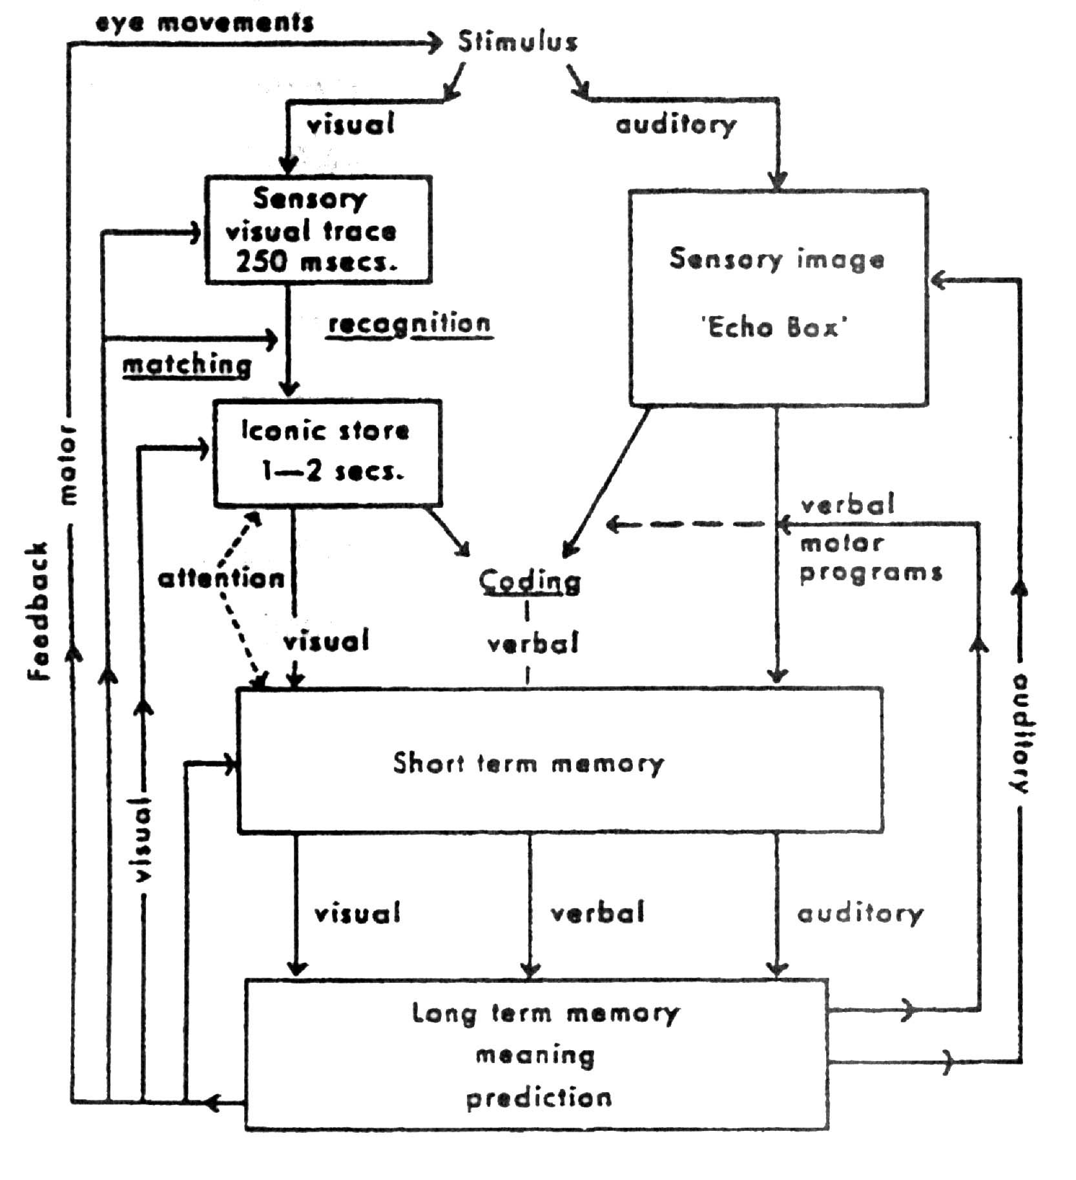

Figure 1. Information processing model of reading.
REFERENCES

- Gibson, E. J. and Levin, H. (1975). The psychology of reading. Cambridge, MA. The MIT Press.
- Dechnant, E. V. and Smith, H. P. (1977). Psychology in teaching reading. Englewood Cliffs, NJ: Printice-Hall.
- Richards, I. A. (1929). Practical Criticism. New York: Harcourt, Brace and World.
- Holmes, J. A. (1965). Basic assumptions underlying the sub-strata factor theory. Reading Research Quarterly, 1, 5-28.
- Holmes, J. A. and Singer, H. (1964). Theoretical models and trends toward more basic research in reading. Review of Educational Research, 34, 127-155.
- Singer, H. (1969). Theoretical models of reading. Journal of Communication, 19, 134-156.
- Davis, F. B. (1968). Research in comprehension in reading. Reading Research Quarterly, 3, 499-545.
- Brown, J. (1970). Psycholinguistics. New York: Free press.
- Brown, R. (1973). A first language: The early stages. Cambridge, MA: Harvard University Press.
- Chomsky, N. (1968). Language and the mind. New York: Harcourt Brace Jovanovich.
- Slobin, D. I. (1971). Psycholinguistics. Glenview, IL: Scott, Foresman.
- Goodman, K. S. (1970). Comprehension-centered reading. Claremont Reading Conference Yearbook, 34, 125-135.
- Chomsky, N. and Halle, M. (1968). Sound patterns of English. New York: Harper and Row.
- Abdullayev, A. A. (1998). Text, Meaning, and Understanding: A Communicative and Cognitive Approach, Alpha Print, Minneapolis.
- Ruddell, R. B. (1974). Reading-Language instruction: Innovative practices. Prentice-Hall, NJ.
- Chaplin, J. P. and Krawwiec, T. S. (1979). Systems and theories of psychology. New York.

Х ц л а с я

ИНФОРМАСИЙАНЫН ЮТЦРЦЛМЯСИ ВЯ МЯТН
(МЮВЪУД ЯДЯБИЙЙАТЫН ТЯЩЛИЛИ)

Яфган АБДУЛЛАЙЕВ
(Хязяр Университяси, Азярбайъан)

Мягалядя мятнлярдя информасийанын ютцрцлмясиня аид олан ясасян цч тип ядябиййаты нязярдян кечирилир. Бунлар ашаьыдакылардыр:
- Биринъи груп ядябиййатда бу проблемля ялагядар тарихи йанашмалар юйрянилир вя мцасир дюврдя анлама моделляри вя нязяриййяляр эюздян кечирилир.
- Икинъи груп ядябиййатда мятнлярдя информасийанын ютцрцлмяси просесиндя йахын йаддаш модели арашдырылыр.
- Цчцнъц груп ядябиййатда охумаг баъарыьы йахшы вя пис олан охуъулар арасында олан фяргляр юйрянилир.
Мцяллиф гейд едир ки, охуйуб анлама ясасян мятндян чыхарылан мяна кими нязярдян кечирилир. Бурада охуъу анламаны мярщяля-мярщяля тамамлайыр: сюз + ъцмля + параграф. Бу мярщяляляр заманы охуъу йазычынын ниййятини баша дцшцр вя ону юзцнцн анлама системиня ютцрцр. Демяк охуйуб анлама сюз символлары иля мянанын ассосиасийасыны, охунан параграфлары контексдя верилян мянасынын гиймятляндирилмясини, мцмкцн мяналар ичярисиндян даща дцзэцн мянанын сечилмясини шяртляндирир.
Мцяллиф аналаманын статистик моделлярини, лингвистик моделлярини, информясийанын ютцрцлмяси моделлярини арашдырыр, онларын анлама просесиндя ойнадыьы ролу эюсятярир. Анлама просесиндя “йухарыдан ашаьыйа” вя “ашаьыдан йухарыйа” принсипляринин мятни охуйуб баша дцшмякдя гаршылыглы щярякят етмялярини эюстярян мцяллиф бир нечя йени моделин йаранмасыны тяклиф едир. Бу моделлярдян информасийанын ютцрцлмясинин интерактив моделлярин даща бюйцк ящямиййят кясб етдийини эюстярир. Мятнин анланмасында беля моделляринин ишлянмяси контексти анламаны асанлашдырыр, охуъулар верилян информасийа щаггында мцлащизяляр йеритмякдя чятинлик чякмирляр. Охуъуларын бу башланьыъ мцлащизяляри ясасян щярфлярин, сюзлярин, сюз бирляшмяляринин, ъцмлялярин вя щятта бцтцн параграфын структуру щаггында олур. Структурдан башланан инфромасийалар ашкар олунан кими илкин мцлащизяляр йа эцъляндирилир, йа да зяифляндирилир.
Мцяллиф инфромасийанын верилмяси моделинин схемини яйани олараг эюстярир вя бу моделин спесифик хцсусиййятлярини изащ едир.

